**STRATEGIES FOR COEXISTING: JUVENILE PINK AND CHUM SALMON DIETS AND INTERACTIONS IN A CHALLENGING SECTION OF COASTAL MIGRATION**

by

Vanessa Rose Zahner

B.Sc., The University of British Columbia, 2015

A THESIS SUBMITTED IN PARTIAL FULFILLMENT OF

THE REQUIREMENTS FOR THE DEGREE OF

MASTER OF SCIENCE

in

THE FACULTY OF GRADUATE AND POSTDOCTORAL STUDIES

(Oceanography)

THE UNIVERSITY OF BRITISH COLUMBIA

(Vancouver)

Current draft version: October 6th, 2020

© Vanessa Rose Zahner, 2020

The following individuals certify that they have read, and recommend to the Faculty of Graduate and Postdoctoral Studies for acceptance, a thesis/dissertation entitled:

|  |
| --- |
| **STRATEGIES FOR COEXISTING: JUVENILE PINK AND CHUM SALMON DIETS AND INTERACTIONS IN A CHALLENGING SECTION OF COASTAL MIGRATION** |

|  |  |  |
| --- | --- | --- |
| submitted by | Vanessa Rose Zahner | in partial fulfillment of the requirements for |
| the degree of | Master of Science | |
| in | Oceanography | |

**Examining Committee:**

|  |
| --- |
| Brian P.V. Hunt, Institute for the Oceans and Fisheries |
| Co-supervisor |
| Evgeny A. Pakhomov, Earth and Ocean Sciences |
| Co-supervisor |
| Colin K. Levings, Institute for Resources, Environment and Sustainability |
| Supervisory Committee Member |
| TBD *****! |
| Additional Examiner |

# Abstract

TBD (word count 350 max)

# Lay Summary

TBD (word count 150 max)

# Preface

This thesis research was the independent, original and unpublished work of Vanessa Rose Zahner. Co-supervisors Dr. Evgeny Pakhomov and Dr. Brian Hunt helped shape the initial project ideas and layout of fish sample sites. The research was done in collaboration with the Hakai Institute’s Juvenile Salmon Program to gain a better understanding of the early marine migration of salmon. Hakai field crews at Quadra Island Station and Salmon Coast Field Station collected juvenile outmigrating salmon and lab crews performed necessary dissections. The fish sampling was approved by UBC’s Animal Care Committee, Protocol A19-0025, and under the DFO license XR 63 2019. Sample processing for zooplankton taxonomy was performed by Andrea Le, Samantha James, Jihyun Kim and Jessica Schaub. All of the salmon stomach content processing, data analysis and writing was done solely by Vanessa Rose Zahner. The raw dataset of salmon stomachs and analysis code are accessible at: <https://github.com/vanzahner/pink-chum-diets>. (NEEDS HAKAI PACKAGE WITH DOI)

# Table of Contents

Abstract iii

Lay Summary iv

Preface v

Table of Contents vi

List of Tables ix

List of Figures xi

List of Illustrations xiv

List of Symbols xv

List of Abbreviations xvi

Glossary xvii

Acknowledgements xviii

Dedication xix

Chapter 1: Introduction 1

1.1 Historical salmon coexistence 1

1.2 Salmon species life history 1

1.3 Current state of salmon stocks 1

1.4 Salmon early marine migration 1

1.5 Pink and chum salmon feeding and competition 1

Chapter 2: Juvenile pink and chum salmon divide prey resources in response to poor foraging conditions 2

2.1 Introduction 2

2.2 Methods 6

2.2.1 Field sampling 6

2.2.2 Zooplankton and salmon stomach content analysis 8

2.2.3 Data analysis 9

2.3 Results 11

2.3.1 Environmental conditions and zooplankton 11

2.3.2 Salmon diet composition 12

2.3.3 Salmon health 14

2.3.4 Diet overlap between pink and chum salmon 16

2.4 Discussion 16

2.4.1 Diets in contrasting foraging conditions 17

2.4.2 Competition in contrasting foraging conditions 20

2.4.3 Trophic niches of juvenile pink and chum salmon 21

2.5 Conclusion 23

2.6 Tables 24

2.7 Figures 28

Chapter 3: Salmon trophic interactions shift with prey phenology and migration timing 38

3.1 Introduction 38

3.2 Methods 40

3.2.1 Field sampling 40

3.2.2 Zooplankton and salmon stomach content analysis 42

3.2.3 Data analysis 43

3.3 Results 44

3.3.1 Environmental conditions 44

3.3.2 Zooplankton 44

3.3.3 Salmon diet composition 45

3.3.4 Salmon stomach fullness 45

3.3.5 Juvenile salmon condition 46

3.3.6 Diet diversity of juvenile salmon 46

3.4 Discussion 46

3.4.1 Seasonality and prey phenology 46

3.4.2 Interannual variability 47

3.4.3 Predator and prey sizes 47

3.4.4 Salmon trophic interactions 47

3.5 Conclusion 47

3.6 Tables 48

3.7 Figures 52

Chapter 4: Conclusion 60

4.1 Knowledge gap of juvenile pink and chum salmon competition 60

4.2 Diets of juvenile pink and chum salmon in contrasting foraging conditions 60

4.3 Trophic interactions of pink and chum salmon during outmigration 60

4.4 Pink and chum salmon as ecosystem indicators 60

References 61

Appendix 70

# List of Tables

Table 2.1 Survey dates, salmon sample sizes, dates, environmental surface data, and zooplankton biomass by size fraction. 24

Table 2.2 Zooplankton relative abundance (expressed as percent) at each site, summarized by the main groups. 25

Table 2.3 Diet composition summary by average relative wet weight (expressed as percent) of the main groups of prey for pink (PI) and chum (CU) salmon at each site. 26

Table 2.4 Salmon biological data including wet weight (WW), fork length (FL), gut fullness index (GFI), showing mean and standard error, the number of empty stomachs, and percent dietary overlap between pink and chum salmon at each site. 27

Table 3.1 Sampling during salmon outmigration (May to July) through the Discovery Islands and Johnstone Strait in 2015 and 2016. 48

Table 3.2 Zooplankton relative abundance (expressed as percent) by major groups. 49

Table 3.3 Summarized salmon biological data for 2015-2016 in DI-JS, including fork length (FL), wet weight (WW), condition factor K, gut fullness (GFI), number of empty stomachs, dietary overlap between species and richness (number of prey categories), expressed as mean ± standard deviation. 50

Table 3.4 Diet composition summary (% wet weight) of juvenile salmon by site and year. 51

Table A.1 Diet composition (% wet weight) summary of juvenile salmon for each sampling date 2015-2016. 70

# List of Figures

Figure 2.1 Map of salmon survey stations in the Discovery Islands and Johnstone Strait. Inset map (left) shows the British Columbia coast with the study region highlighted in red. 28

Figure 2.2 Temperature (black) and salinity (red) values paired with the salmon surveys. The sites are listed along the salmon migration pathway from left to right. 29

Figure 2.3 Biomass of zooplankton, displaying total biomass and contribution by size fractions. “X” indicates that data were missing for site J02. 30

Figure 2.4 Average relative abundance of zooplankton groups. “Other” includes cladocerans, barnacle larvae and euphausiid eggs. 31

Figure 2.5 Salmon condition factor K, the red dotted line separates fish in good condition (high weight relative to length, >1) and fish in poor condition (low weight relative to length, <1). 32

Figure 2.6 Average relative biomass of the main prey groups for juvenile pink (top) and chum salmon (bottom), at each site along the migration route. The ‘Other’ group includes prey such as cyclopoids, fish, polychaetes and pteropods. 33

Figure 2.7 Non-metric multidimensional scaling (NMDS) ordination of juvenile pink and chum salmon diet composition. Each point represents one salmon stomach, colored by site, and ellipses show standard deviation by region. “Stress” indicates how well the distances between points were retained when displayed in two-dimensions and for this plot, the stress was 0.17. 34

Figure 2.8 Cluster analysis of juvenile pink and chum diet composition. 35

Figure 2.9 Gut fullness index (GFI) of juvenile pink and chum salmon. Box plots show the mean (black bar), interquartile range (boxes) and 1.5*inter-quartile range (whiskers) of salmon GFI. The overlaid dark red line indicates dietary overlap between pink and chum salmon (secondary y-axis). 36

Figure 2.10 Cumulative prey abundance curves for juvenile salmon at each site location. Note: All sampling events included 10 salmon, but empty stomachs detract from total number of stomachs. 37

Figure 3.1 Map of sampling sites for Discovery Islands and Johnstone Strait during May to July 2015-2016. Inset map (left) shows B.C. coast with study location in red. 52

Figure 3.2 Temperature (black) and salinity (red) variables paired with salmon surveys in DI and JS, during the outmigration period in 2015 and 2016. 53

Figure 3.3 Zooplankton biomass by size fraction for 2015-2016. “X” indicates missing data. 54

Figure 3.4 Zooplankton relative abundance for site and sampling period in 2015-2016. “X” indicates missing zooplankton data to pair with salmon data. Note: June 5th and 7th 2015 in DI was shown as two separate sampling events due to pink and chum being sampled on different dates. 55

Figure 3.5 Diet composition of major prey groups by relative biomass of juvenile pink (“PI”, outlined in pink) and chum (“CU”, outlined in dark green) salmon during outmigration in 2015-2016. 56

Figure 3.6 NMDS (simple version, will update later to separate pink & chum and years clearly) 57

Figure 3.7 Gut fullness indices (GFI) for juvenile pink and chum salmon in DI-JS, 2015-2016. 58

Figure 3.8 Juvenile salmon condition during outmigration through DI-JS in 2015-2016. The red dotted line separates fish in good condition (high weight relative to length, >1) and fish in poor condition (low weight relative to length, <1). 59

# List of Illustrations

Illustration 1: (Placeholder) Haida pink and chum salmon by SGidGang.Xaal *Shoshannah Greene*. xix

# List of Symbols

± Plus-minus

μm Micrometre (10-6 m)

‰ Parts per thousand

°C Degrees Celsius

# List of Abbreviations

AHC Agglomerative hierarchical clustering

B.C. British Columbia

BW Body weight

DI Discovery Islands

DI-JS Discovery Islands and Johnstone Strait

FL Fork length

GFI Gut fullness index

JS Johnstone Strait

mm Millimetres

NMDS Non-metric multidimensional scaling

NSoG Northern Strait of Georgia

PSI Percent similarity index

QCSt Queen Charlotte Strait

SE Standard error

SoG Strait of Georgia

WW Wet weight

YSI Yellow Springs Instrument

# Glossary

Littoral Nearshore

# Acknowledgements

TBD (committee, lab mates, lab volunteers, friends/family, funding, UBC FNHL, and salmon)

# Dedication

*Naanii Sandy – Kuniisii – Saa’laanaa –*

*Haw’aa dalang ‘waadluwaan ahl kil ‘laagang*

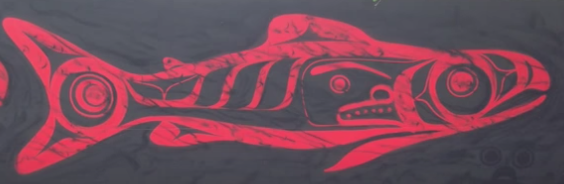

**

Illustration 1: (Placeholder) Haida pink and chum salmon by SGidGang.Xaal *Shoshannah Greene*.

## Introduction

### Historical salmon coexistence

Since time immemorial, humans have coexisted with Pacific salmon (Oncorhynchus spp.), with archaeological evidence dating back over 10,000 years for anadromous salmon use. Both salmon and humans existed in areas of glacial refugia during the last major ice age, co-evolving and adapting into the expanse of complex river and lake systems of the modern age. Therefore, salmon stocks have evolved to their unique environments over thousands of years and humans played a role in shaping that evolution and understood the cyclical patterns of salmon. However, in the past couple hundred years, humans have since altered salmon habitats, the climate, the size and health of salmon stocks due to major industrialization and over-exploitation. Therefore, understanding the survival of salmon is more complex than ever in the face of climate change and threatened stocks, and deep knowledge is crucial to improve salmon management.

### Salmon species life history

…

### Current state of salmon stocks

…

### Salmon early marine migration

…

### Pink and chum salmon feeding and competition

…

## Juvenile pink and chum salmon divide prey resources in response to poor foraging conditions

### Introduction

Pacific salmon (*Oncorhynchus* spp.) are irreplaceable to the cultures, food security and ecosystems within the Pacific Northwest, migrating from freshwater to the Pacific Ocean then returning to their natal habitats, thereby bringing important nutrients into multiple environments

(Marushka et al., 2019; Quinn, 2018; Wyllie de Echeverria & Thornton, 2019). While pink (*O. gorbuscha*) and chum salmon (*O. keta*) currently have the highest abundance and biomass (respectively) of all salmon species in the North Pacific, there have been regional declines of salmon stocks in British Columbia (Malick & Cox, 2016; Ruggerone & Irvine, 2018). Commercial fisheries for salmon have decreased in response to declining stocks and traditional harvest for many B.C. First Nations have also been reduced (Garner & Parfitt, 2006; Michael C. Healey, 2009). Despite ongoing research on salmon, predictions of adults returning to spawn are highly variable, often lower than expected, and salmon fisheries have become increasingly difficult to manage (Beamish 2017).

Chum and pink salmon are species that leave freshwater soon after fry emerge, heading straight towards the estuary and the ocean at a relatively small size (Groot & Margolis, 1991). The juveniles must contend with the physiological challenges of smoltification, multiple potential predators, and a new foraging environment (Levings, 2016). Mortality for salmon smolts can be high, and research has shown that growth during the early marine phase is an important determinant of the cohort strength during the first winter at sea and the likelihood of adult survival (Beamish & Mahnken, 2001).

Prey availability and salmon foraging behaviour are important factors for growing quickly during the early marine life (Brodeur, 1990). Patchiness of zooplankton in the ocean leads to relatively generalist salmon feeding (Osgood et al., 2016). However, there are energetic trade-offs and decisions regarding effort required to capture prey, leading to the species specific trophic niches (Gill, 2003). Indeed, salmon species have unique foraging behaviour and preferences, allowing them to portion available prey resources (Healey, 1991). For example, pink, chum and sockeye salmon are planktivorous during early marine life, whereas chinook and coho salmon are piscivorous (Daly et al., 2019).

Pink and chum diets vary in response to prey availability, size, intra- and interspecific competition (Beamish et al., 2003). Small pink and chum salmon often forage in the nearshore coastal environment, consuming prey such as harpacticoids (Godin, 1981; Healey, 1979), shifting to larger calanoids, decapods, appendicularians, amphipods and euphausiids as salmon size increases (Manzer, 1969; Perry et al., 1996). Pink and chum salmon therefore have the potential to compete for food or occupy different trophic niches to reduce competition, which has been studied with stable isotopes but not stomach contents (Jenkins, 2011; Pocheville, 2015). Stable isotope analysis of salmon muscle tissue reflects more broad diet patterns of carbon and nitrogen signatures of zooplankton prey integrated over longer time periods, whereas stomach analysis is a more refined snapshot that can reflect the nuances of specific zooplankton prey.

Niche can be defined as a combination of the conditions allowing a species to satisfy the minimum requirements for survival and the impact of that species on ecosystem processes (Chase & Leibold, 2003). Therefore, the “trophic niche” of a salmon species can be identified as prey resources consumed to meet energetic demands and the effect of salmon foraging on the zooplankton community and other species (Jenkins, 2011). Essentially, trophic niche is an organism’s role within the food web; it can be dynamic over time and coexisting species cannot occupy the same niche as this leads to a competitive exclusion (Hardin, 1960). Previous studies have shown that climate forcing and prey availability may influence competition and trophic niches of juvenile pink and chum salmon, when under poorer feeding conditions salmon species tend to have higher diet overlap by competing for the same resources (Gulbransen, 2014; Jenkins, 2011).

Pink salmon are an example of dominant competitors for food resources. They actively feed on crustacean zooplankton and in high abundance years can cause trophic cascades (Batten et al., 2018; Ruggerone & Nielsen, 2004). Emerging studies on competition have shown pink salmon to negatively affect the growth and survival of other salmonids, herring, sea birds and killer whales (Beamish et al., 2010; Pearson et al., 2012; Ruggerone et al., 2019; Springer et al., 2018). Chum salmon, on the other hand, have more flexible feeding strategies, with the tendency to prey shift towards gelatinous zooplankton in response to competition or limited food resources (Johnson & Schindler, 2009; Tadokoro et al., 1996). Chum salmon have a substantially larger stomach than other salmon which enables them to specialize on large gelatinous prey to meet their energetic requirements (Welch, 1997). While these trends for pink and chum salmon have been shown in adults, similar research is limited for outmigrating juveniles.

The zooplankton communities migrating salmon encounter are largely supported by bottom up processes such as ocean mixing, nutrients, temperature, salinity, and phytoplankton productivity (Mackas et al., 2001). In southern British Columbia, the majority of pink and chum salmon originate from the Fraser River and the juveniles migrate northward through the Strait of Georgia, a seasonally stratified and productive region (DFO, 2020; Harrison et al., 1983). North of the Strait of Georgia (SoG) are the complex and tidally mixed areas of the Discovery Islands (DI) and Johnstone Strait (JS), which differ in oceanographic properties and zooplankton communities (Khangaonkar et al., 2017; Mahara, 2018). Specifically, DI are characterized as warmer and fresher, with small zooplankton and meroplankton dominating, relative to JS, which is cooler and more saline, with higher proportions of calanoid (larger) copepods (Mahara, 2018). Recent studies have hypothesized these regions to be a “trophic gauntlet” for juvenile salmon, and sockeye salmon have indeed been demonstrated to be food limited in these tidally mixed waters, with gut fullness <0.5% of their body weight (James et al., 2020; Mckinnell et al., 2014). Salmon then migrate through the Queen Charlotte Strait (QCSt), where they may be able to forage successfully and recover from the food shortages experience in DI and JS (Mcqueen & Ware, 2006). Therefore, salmon are able to survive this challenging route of DI-JS since it is book-ended with productive feeding conditions in the northern Strait of Georgia (NSoG) and QCSt. Since pink and chum salmon have similar foraging and migration patterns to sockeye, they are also exposed to the trophic gauntlet potentially increasing competition for resources and affecting juvenile growth and survival (Healey, 1991).

The conditions salmon encounter in this region of B.C. are representative of environments encountered by early marine phase juvenile salmon in other regions of the Northeast Pacific (Brodeur et al., 2007). For example, Southeast Alaska has a similar coastal oceanography, with inlets, channels, archipelagos, and high amounts of tidal mixing that can influence salmon diets (Weingartner et al., 2009). In Icy Strait, Southeast Alaska, juvenile pink and chum salmon diets comprised calanoid copepods, euphausiids, appendicularians and amphipods (Orsi et al., 2004; Sturdevant et al., 2004). Therefore, not only does the DI-JS region represent an important section of the salmon migration route, but it is a microcosm of coastal conditions experienced by juvenile pink and chum salmon along the Northeast Pacific coast.

This study addressed a knowledge gap in the foraging biology of juvenile pink and chum salmon across contrasting feeding conditions in tidally mixed waters during coastal migration.

Specifically, this study aimed to compare juvenile pink and chum salmon (a) diets and trophic niches, (b) foraging success, and (c) interspecific competition, in areas of contrasting foraging conditions in the southern B.C. The prediction was that low prey availability would lead to juvenile pink and chum salmon competition and separation by niche.

### Methods

#### Field sampling

The Hakai Institute’s Juvenile Salmon Program was established in 2015 as a collaboration between the Hakai Institute, the University of British Columbia, Simon Fraser University, the University of Toronto and Salmon Coast Field Station. This ongoing program annually samples juvenile salmon as they migrate through the Discovery Islands and Johnstone Strait during the main outmigration period (May to July). The objective of the program was to improve understanding of the early marine phase of Pacific salmon, particularly factors contributing to health and survival (Hunt et al., 2018). This study focussed on 2016, which had the largest spatial sampling coverage in an effort to resolve the primary migration pathways through the region. The previous year, 2015, had similar spatial sampling coverage but there was expected and observed lower pink abundance, due to their biennial life patterns.

In the Discovery Islands, 12 sites were sampled in 2016, and in Johnstone Strait, 10 sites were sampled, to provide coverage of all possible salmon migration routes through these regions (Hunt et al., 2018). Sample coverage extended from the northern Strait of Georgia, multiple routes in the Discovery Islands, through Johnstone Strait to the beginning of Queen Charlotte Strait. For this study, 6 sites (three from each region) were selected, in order to obtain a sample size of 10 pink and 10 chum per set (n=120 total) while still acquiring sufficient coverage for each region, focusing on the central pathway of Discovery Islands through Okisollo Channel (Figure 2.1). The entire length of the sample area encompasses 140 km, with the distance between sites ranging from 15 to 30 km and a distance between the two regions around 50 km. Samples for this analysis were selected from mid-June (Table 2.1) to align with the peak out-migration of salmon, when 50% of a species migrates through the area (Johnson et al., 2019). The peak outmigration of juvenile chum salmon was June 10th, 2016 and pink salmon, June 11th, 2016 (Table A.1 * not yet created).

Fish were captured using a purse seine with bunt dimensions of 27 m × 9 m with 13 mm mesh and tow area dimensions of 46 m × 9 m with 76 mm mesh. Once arrived at a site, weather and sea state were recorded, followed by a visual survey of salmon surface activity. The purse seine net was then set on a targeted school of fish. Up to 30 sockeye, 10 pink and 10 chum salmon were retained, and the remaining salmon were counted and released (Hunt et al., 2018). All retained fish were individually euthanized with tricaine methane sulfonate (MS-222) upon removal from the seine net, lengths and weights recorded, and preserved at -196 oC with liquid nitrogen in a dry shipper until the salmon samples were stored in the -80 oC freezer at the lab.

A YSI instrument (model #15B102233 and 15C100324) was used to measure temperature and salinity at the surface and 1-meter depth, recorded while salmon were held for processing in the net. Once the purse seine set had been complete, zooplankton were sampled with a 50 cm diameter ring net with 250 μm mesh net, towed horizontally at the surface. A General Oceanic flowmeter was attached to the zooplankton net to calculate volume filtered for each sample tow. The zooplankton collected were then preserved in 4% formaldehyde for subsequent analysis.

#### Zooplankton and salmon stomach content analysis

In the lab, zooplankton samples were poured over sieves and separated into 250 μm, 1000 μm and 2000 μm size fractions before being weighed and analyzed. Wet weights were measured to the nearest 0.1 mg on an analytical balance, with non-gelatinous and gelatinous groups weighed separately. If necessary, each size fraction of zooplankton was subsampled with a Motodo plankton splitter. Zooplankton were identified to life stage and the finest taxonomic resolution possible, each group was then enumerated and measured with an ocular micrometer.

Wet weight and fork length were recorded for juvenile salmon before dissection to remove the stomachs, which were preserved in 95% ethanol. Prior to analysis, salmon stomachs were removed from ethanol and soaked for 30 minutes in tap water to reduce the brittleness of the sample. The stomach was then dissected open and the food contents removed. The entire food bolus was weighed on an analytical balance and wet weight recorded to the nearest 0.1 mg. The bolus was then placed on a petri dish with water added, and prey rearranged by species, size, life stage and digestive state. Digestive states were defined as 1) fresh prey, intact, 2) semi-fresh prey, with lost appendages or color, 3) semi-digested prey, only identifiable to group, and 4) fully digested prey, unidentifiable. If prey could not be identified to species, it was identified to the most detailed taxonomic group possible, e.g. Ctenophora and Cnidaria jellyfish, collectively grouped as “gelatinous” hereafter. For each prey group, minimum and maximum lengths were measured with an ocular micrometer, individuals were counted, and the group wet weight recorded to nearest 0.1 mg. If a stomach sample had over 1,000 prey of similar size, a ¼ subsample was processed, after removing and recording large and/or rare prey.

#### Data analysis

The spatial variation in prey composition was analyzed using a multivariate approach. Prior to the analysis, rare taxonomic prey categories (occurring in less than three stomachs) were combined into higher level groupings, ignoring “digested food.” Fish stomach content wet weight was multiplied by 1.54 to correct weights for water loss after storage in ethanol (James, 2019). Relative prey biomass for each stomach was calculated and arcsine square root transformed before calculating Bray-Curtis dissimilarity. The dissimilarity matrix was used for non-metric multidimensional scaling (NMDS) ordination and agglomerative hierarchical clustering (AHC). The optimal number of clusters for AHC was determined from silhouette and gap statistic methods. Outlier samples that were excluded from the NMDS ordination were determined from single clusters in the AHC that had >95% dissimilarity to all other samples.

In addition to the multivariate statistics, various indices were calculated from the raw data. Gut fullness indices (GFI) were calculated for each fish, expressed as percent body weight:

GFI = (food bolus weight / fish weight) * 100

Fulton’s condition factor K comparing length-weight relationships of salmon was calculated as:

K = 100,000 * fish weight / (fish fork length)3

Weight was measured in grams and fork length in millimetres, K=1 indicates average condition, >1 means relatively healthy and <1 was poor condition (Beamish et al., 2012; Jones et al., 1999). The Schoener percent similarity index (PSI) for species diet overlap was calculated for each site:

PSI = [Σ (minimum preyip, preyic)] * 100

Where preyip was the proportion by weight of prey *i* in pink salmon stomachs and preyic was the proportion by weight of prey *i* in chum salmon stomachs (Chipps & Garvey, 2006; Krebs, 2013).

The empty stomachs (those with no identifiable prey) in this study were excluded from the multivariate dissimilarity calculations but were included in the calculation of the above indices. The prey taxonomic detail was retained in analyses, but for summary tables and figures, “other” was prey grouped together that does not contribute substantially to diets (<10% weight), e.g. fish larvae/eggs, amphipods, barnacle larvae, bivalve larvae, cladocerans, pteropods, and polychaetes. Diet richness was determined through cumulative prey curves for juvenile pink and chum salmon stomachs. All analyses were performed in R (v4.0.2.), using the *vegan* package v2.5-6 (Oksanen et al., 2019; R Core Team, 2020).

### Results

#### Environmental conditions and zooplankton

The environment of Discovery Islands was characterized as warmer and fresher and Johnstone Strait was colder and more saline (Table 2.1). The site nearest the northern Strait of Georgia, D07, had high freshwater influence (salinity = 24.9) and warmest temperature (17oC), potentially indicative of stratified conditions (Table 2.1; Figure 2.1; Figure 2.2). The other Discovery Islands sites (D09 and D11) cooler (< 12oC) and saltier (> 28.5‰), indicating that they were in the tidal mixing zone. In the Johnstone Strait and near Queen Charlotte Strait, the sites were consistently cold and saline due to mixing, with temperatures ranging from 9.9-10.4oC and salinities from 30.9-32.2‰ (Table 2.1; Figure 2.2).

Different zooplankton communities by biomass characterized Discovery Islands and Johnstone Straight waters. The zooplankton biomass throughout this area was mostly composed of small zooplankton, in the 250 μm size fraction or gelatinous zooplankton from the 2000 μm size fraction (Figure 2.3). At D07, there were almost equal amounts of small (250 μm) and gelatinous (2000 μm) zooplankton biomass, whereas only 250 μm zooplankton comprised D09. At D11 and J06, there were similar amounts of 250 μm and 2000 μm gelatinous zooplankton and at J08, the composition was dominated by small 250 μm zooplankton. At sites D11, J06, and J08, there were 1000 μm and 2000 μm non-gelatinous zooplankton present but biomass never exceeded 10 mg/m3 (Table 2.1). The total zooplankton biomass was relatively low throughout the study area (Table 2.1), ranging from 128.6 mg/m3 in Johnstone Strait (J06) to 569.0 mg/m3 in Discovery Islands (D09).

The zooplankton community composition varied regionally in both the Discovery Islands and Johnstone Strait. While calanoids always dominanted zooplankton across the region, the highest proportions of calanoids (59.3-77%) were observed in the Johnstone Strait (J06 and J08; Figure 2.4; Table 2.2). Conversely, the Discovery Islands were characterized by higher proportions of appendicularians (8.6-10.9%) compared to Johnstone Strait (< 3%) . Also, there was higher amounts of bivalve veliger larvae at D07 (30.3%) and a dominance of small cyclopoid copepods at J02 (54.4%;Table 2.2). Finally, there was often high amounts of ‘other’ prey, that included small zooplankton such as barnacle larvae and cladocerans (Figure 2.4).

#### Salmon diet composition

At the first DI site location D07, near the northern Strait of Georgia, chum salmon had predominately consumed appendicularians *Oikopleura* sp. (91% of diet by weight), whereas pink salmon diets were more diverse including calanoid copepods (19.8%), decapod larvae (28.4%) and ‘other’ small prey (21.1%; Table 2.3). Further north, at the Discovery Islands sites D09 and D11, both salmon species continued to consume calanoids and appendicularians, in different proportions, with chum salmon having a high contribution of *Oikopleura* (44.2-64.6%) and pink salmon consistently preying upon calanoids (30.2-57.2%; Figure 2.6). At site D09, pink salmon consumed 25.1% harpacticoid copepods and 12.3% insects, indicating nearshore feeding.

At the first Johnstone Strait site (J06) chum salmon diet comprised almost entirely gelatinous prey (96.2%), while pink salmon diets had a high contribution of nearshore prey, such as harpacticoids (19.3%) and arachnids (16.7%; Table 2.3; Figure 2.6). At the Johnstone Strait site J08, chum salmon diets still had a high contribution of gelatinous prey (76.1%) but, in addition, had higher amounts of large calanoid copepods (15.7%), while pink salmon predominantly ate calanoids (85.5%). There was a complete diet shift at the most northerly Johnstone Strait site (J02), where both salmon species consumed, albeit in different proportions, calanoids (pink 61.9%, chum 18.7%), chaetognaths (pink 5.5%, chum 21.3%) and euphausiids (pink 29.6%, chum 53.5%; Table 2.3; Figure 2.6).

The NMDS plot demonstrated that the diet composition of salmon was firstly influenced by differences between the two regions (Figure 2.7). Within each region, differences were apparent between both site and salmon species. In the Discovery Islands, pink and chum salmon diets separated out, and site was an important factor to a degree of separation, while there were always sites with some dietary overlap between species. In contrast, in Johnstone Strait there was clear separation by both sites and species. The most southern Johnstone Strait site, J06 had high species-specific differences, at J08 species separated to a lesser degree, and at J02 (near QCSt), the similarity between species was high (Figure 2.7).

The cluster analysis largely supported the NMDS results (Figure 2.8). Diets from Johnstone Strait and Discovery Islands mostly separated at the ~ 85% level of dissimilarity. In the Discovery Islands, sites tend to group together within clusters, and with the exception of a few D11 chum samples that cluster out separately, chum salmon diets in DI were in one cluster with a maximum of 60% dissimilarity to one another (Figure 2.8). Pink salmon in the Discovery Islands within D09 and D11 were highly variable, spread over multiple clusters, which also had overlap and similarity to site J06. Whereas, D07 (near NSoG) pink salmon group together within one cluster (< 60% dissimilarity), with the exception of one outlier cluster with 96% dissimilarity. In Johnstone Strait, the separation between sites was more distinct. There was one cluster for both pink and chum diets in J02, near QCSt (< 60% dissimilarity). Conversely, for the other Johnstone Strait sites pink and chum salmon clustered separately. At J08, diets had < 55% dissimilarity within species but 82% between species. At J06, there was high dissimilarity between pink salmon diets (> 79%), while chum diets had <55% dissimilarity.

#### health

Gut fullness was consistently low throughout the Discovery Islands and Johnstone Strait, with the exception of full and distended stomachs at the last site, in southern Queen Charlotte Strait (Figure 2.9). Gut fullness indices (GFI) for both species were generally below 0.5% body weight throughout the Discovery Islands, and J06, the most southerly Johnstone Strait site. At the mid-Johnstone Strait site J08, the GFI increased to ~ 1% body weight (pink 1.13% ± 0.06, chum 1.28% ± 0.04). At J02, GFI increased to ~ 7% body weight GFI at site J02 (pink 7.46% ± 0.19, chum 6.20% ± 0.11). Microplastics and other non-digestible objects (glass, a rock) were found in 10% of all juvenile pink salmon stomachs, observed in salmon from the three DI sites and J06, the sites with the lowest GFI, but no chum salmon were found to have eaten any non-food objects.

Empty stomachs were found throughout the Discovery Islands and the first Johnstone Strait site (Table 2.4). Empty stomachs were recorded for pink salmon at D07 (20%) and J06 (40%), and for chum salmon at D09 (30%) and D11 (30%). There were no sites where empty stomachs occurred for both pink and chum salmon simultaneously. By region, 7% of pink salmon stomachs were empty and 20% of chum salmon in the Discovery Islands, while in Johnstone Strait no empty stomachs were recorded for chum salmon compared to 13% for pink salmon. Ten percent of all juvenile salmon stomachs analysed in this study were found empty.

#### Diet overlap between pink and chum salmon

Dietary overlap between pink and chum salmon was relatively low and consistent in the Discovery Islands and shifted from low to high levels in Johnstone Strait (Figure 2.9). At the first site of the migration route, D07, dietary overlap reached 24.9%. This increased to 33.0% at D09 and then decreased to 21.7% at D11. The lowest dietary overlap, 4.8%, was observed at J06 (Figure 2.9). Dietary overlap at mid-Johnstone Strait J08 was 14.1% and the final site near the entrance to Queen Charlotte Strait J02 had the highest diet overlap of 59.8%. In summary, the Schoener overlap index showed consistently low to modest diet overlap between juvenile pink and chum salmon at all sites with the exception of J02.

The dietary richness or number of taxa found in the stomachs, demonstrated that pink salmon had a broader range of prey in the diets than chum salmon at every location (Figure 2.10). The site with the highest prey richness for both salmon species was the most northerly site, J02, and the lowest diet richness occurred at J06 for chum salmon and D11 for pink salmon. Johnstone Strait generally had higher diet richness than Discovery Islands, likely due to the diversity of small and large calanoid copepods. Overall, pink salmon diets were about twice as rich as chum salmon.

### Discussion

This study examined juvenile pink and chum salmon stomachs to characterize diets during the 2016 peak outmigration through the Discovery Islands and Johnstone Strait routes. Contrasting ocean conditions were observed in the temperature and salinity properties of the regions and the zooplankton biomass was higher in Discovery Islands than Johnstone Strait (James et al 2020). The aims of this research were to compare (a) diets, (b) niches, (c) foraging success, and (d) competition, of pink and chum salmon under these varying foraging conditions. The regional differences in oceanography and zooplankton resulted in clear diet separation for both pink and chum salmon between each of the two major regions of study. The dietary overlap between pink and chum salmon varied from low to high overlap of prey composition in relation to the amount of stomach fullness, with low overlap when foraging levels were low, indicating resource partitioning. These specific points are discussed in more details below.

2.4.1 Pink and chum salmon feeding strategies

In tidally mixed waters, pink and chum salmon had low stomach fullness, prey and niche partitioning between species, with chum occupying a gelatinous niche and pink feeding generally close to the littoral. Although, the northern most site of J02 was shown to be a foraging hot spot for juvenile pink and chum salmon, with high diet overlap between species, the highest diet richness, and high quality of prey species. Prey quality is an important factor for juvenile salmon diets and growth during the early marine phase, and fatty acid contents is a good measure of prey quality. Recent research in the Strait of Georgia on zooplankton quality found large copepods, euphausiids, chaetognaths and hyperiid amphipods to have high fatty acids contents (Costalago et al 2020). Whereas, meroplankton, small zooplankton, and gelatinous zooplankton were lower in nutritional content, and poorer quality prey (Boldt, 2001). Therefore, both the amount of food consumed by salmon and the prey types are important for salmon growth and survival. In this study, salmon consumed higher quality prey at the most northern site near Queen Charlotte Strait and lower quality prey throughout the other study sites.

In other areas with similar coastal conditions, pink salmon had been found to be nearshore foragers upon small crustaceans, while chum salmon often prey switch from crustacean to gelatinous plankton (Godin, 1981; Tadokoro et al., 1996). Previous studies have found harpacticoid and calanoid copepods as primary prey items for both pink and chum salmon (Chebanova et al., 2018; Godin, 1981; Healey, 1979). Recently, a study conducted simultaneously discovered that sockeye salmon diets dominate by *Oikopleura* in the Discovery Islands (James, 2019), which is similar to chum salmon. Furthermore, larger calanoids were dominant sockeye prey in Johnstone Strait (James, 2019), that was similar to the observed pink salmon diet composition. Other research that investigated dietary overlap of multiple species of salmon have found that the pink salmon diet tends to be most similar to either sockeye or chum salmon (Daly et al., 2019).

The trophic niche of juvenile salmon in the Discovery Islands and Johnstone Strait can also be related to the habitat niche when pink salmon forage in the nearshore and chum salmon in the pelagic environment, on gelatinous or crustacean prey. Each sampling set captured salmon likely travelling within the same school(s), however nearshore prey items were found more frequently and in higher proportions in pink salmon diets, including higher prey richness of harpacticoids, insects, arachnids, barnacle larvae, cumaceans, caprellid and gammarid/corophiid amphipods. Pink salmon may consume these smaller, reliable prey since they need to constantly feed in order to achieve growth rates of up to 3.5-7% body weight per day (Beamish et al., 2003; LeBrasseur & Parker, 1964). Since gelatinous prey are often lower in nutritional content than other zooplankton, chum salmon have evolved larger stomachs than other salmon to consume more biomass of jellyfish to benefit off that specific prey source (Welch, 1997). Therefore, it seems pink and chum salmon were genetically predisposed to littoral and gelatinous niches (respectively) when food was scarce. However, niche switching was a norm, when foraging conditions improved and higher quality prey, such as large calanoids and euphausiids, became more readily available. This adaptive flexibility of the trophic and habitat niches of juvenile salmon could be an area for further research and should be investigated further. For example, niche flexibility of other species, in other areas, at different life phases, and compared across seasons and years to understand better its benefits and to include into life-history models of salmon species.

Pink salmon consumption of microplastics, glass, and rocks also reflected nearshore feeding, these foreign objects were found in 5% of all salmon stomachs analyzed. These objects were found at sites D07, D09, D11 and J06, the four sites with empty stomachs. Other studies have found Chinook salmon to have consumed microplastic fibers (Collicutt et al., 2019), none of which were present in this study. The microplastic pieces (0.3 – 2.8 mm) in salmon stomachs in the Discovery Islands and Johnstone Strait were irregularly shaped, which had been shown to impact the fitness of other fish species (Choi et al., 2018). Quantifying the impacts of plastics on salmon and exploring the relationship with plastic consumption to empty stomachs and nearshore foraging holds incredible potential for a new branch of salmon health and conservation research.

2.4.2 Feast or famine: salmon feeding and condition

Juvenile pink and chum salmon were found to have extreme values of stomach fullness in the DI-JS, relative to other locations along the coastal migration routes in the Pacific Northwest. For example, juvenile pink and chum mean gut fullness was found to be 2-4% body weight (BW) in the nearby Broughton Archipelago in 2003 and 2006 (Gulbransen, 2014), 1% BW in Northern B.C. in 2000-2002 (Brodeur et al., 2007), 1-4% BW in Southeast Alaska in 2001 (Sturdevant et al., 2002), and 1.7-1.9% BW in the eastern Gulf of Alaska (Daly et al., 2019). Comparatively, in this study juvenile pink and chum salmon gut fullness averaged < 0.5 % BW in the first five sites (0.35% pink; 0.40% chum) and > 5% BW in QCSt (7.5% pink; 6.2% chum).

This foraging refuge of Queen Charlotte Strait may help juvenile salmon meet their energetic demands for outmigration after a period of potential food limitation and poor food quality. The same site was found to be productive for juvenile sockeye salmon in 2015 (James et al 2020), however, chum salmon experienced low stomach fullness (~1%) elsewhere in Queen Charlotte Strait in 2015 (unpublished data). Therefore, there was likely a physical oceanographic front, where mixed and stratified water masses meet, thereby accumulating zooplankton to form this forage “hot spot” (Perry et al 1983, Franks 1992). However, if ocean conditions change and these refuge areas become unproductive, it can have devastating effects on salmon survival (Beamish et al., 2012; Mckinnell et al., 2014). If juvenile salmon experience an extended starvation period of two weeks, they will not be able to fully recover afterwards (Kuzmenko, unpublished data).

The migration time to get through these regions was around 11 days for sockeye salmon (James et al 2020), and pink and chum are likely comparable but haven’t been studied yet. Pink salmon tend to migrate more quickly than other salmon species due to their shorter life spans, whereas chum tend to remain in estuaries longer (Duffy et al 2005). In this study, there were salmon size differences between regions, as Johnstone Strait is further north than Discovery Islands, however, chum salmon occupied a wider range of sizes, which potentially indicated longer residence periods. Further studies on the migration timing and pathways of pink and chum salmon in this area are required to properly investigate benefits and costs of quick or long migrations on salmon health in areas of food gauntlets and hot spots.

In addition to stomach fullness being low for migrating juvenile salmon in the Discovery Islands and Johnstone Strait, Fulton’s condition factor K was also low throughout both regions. Although there was higher condition factor for D07 chum that indicated good feeding in the northern SoG, although this was not seen in the stomach fullness at this site. The difference in K between pink and chum salmon conditions at D07 may also indicate differing residence times in the Strait of Georgia, with pink salmon moving more quickly through the area. The good condition (for chum salmon) in NSoG, low feeding and condition in DI-JS, followed by high feeding and condition in QCSt for pink and chum salmon, was mirrored by the study done on juvenile sockeye salmon in the same area in 2015, which found food limitation and similar foraging hot spots (James et al., 2020). However, another study on the growth of juvenile salmon found that pink and chum salmon experienced low growth in the Johnstone Strait and Queen Charlotte Strait area during 2012 – 2014 outmigration (Journey et al., 2018). It may be speculated that it may have occurred due to low feeding opportunities but juvenile pink and chum salmon diets in this area had never been analyzed until this current study.

2.4.3 Species competition or coexistence?

In those low foraging conditions, juvenile pink and chum salmon were likely competing for limited resources and employed species-specific strategies in response to the challenging conditions. Chum salmon had been shown to adapt and switch to gelatinous prey in response to inter-specific competition with pink salmon at the adult phase. This study indicated that chum salmon prey switching may occur as early as juvenile stage. The specialization under low foraging conditions was reflected in the low prey richness, low stomach fullness and low dietary overlap between pink and chum salmon along the DI-JS route. In contrast, the site at Queen Charlotte Strait had the opposite trend, with high prey richness, high gut fullness and high dietary overlap between species, indicating a lack of competition likely due to high prey availability (Graham, 2020). Therefore, salmon species potential to compete for limited food resources during early marine migration was dynamic, may shift over time and requires further in-depth research.

Juvenile pink and chum salmon had similar diets when prey availability was high but utilized different foraging strategies when prey availability was low, which was indicative of resource partitioning. Throughout most of the study sites, chum salmon appeared to forage within the gelatinous predator niche, while pink salmon switched to the littoral niche utilizing nearshore insects, harpacticoids, caprellids and gammarids. These niche strategies shifted with the foraging intensity, since at the Queen Charlotte Strait site with ~7% body weight stomach fullness, both species fed very similarly. Therefore, pink and chum salmon were observed to both consume similar and likely higher quality prey, such as euphausiids and large calanoids, in regions of high prey availability but clearly portion the resource space when prey was limited. This strategy would be expected to limit any potential competition but had not yet been explored in nearshore coastal environments for young salmon.

Zooplankton biomass was considerably low throughout Discovery Islands and Johnstone Strait in June 2016 when juvenile pink and chum salmon were migrating through these regions. The zooplankton community composition was not closely reflected in the stomach contents, due to surface net tows unable to capture all relevant salmon prey such as epibenthic harpacticoid copepods, or fish and euphausiids that tend to avoid zooplankton nets. The zooplankton captured were mainly small (250 μm) cyclopoids and calanoid copepods and the differences between the two regions was not as clear of a prey divide compared to the diets. The most representative way of capturing what prey were available for salmon at each location, was through the diets themselves, viewing salmon as “plankton sampling gear” for the ideal prey type and size. An alternative possibility is the potential for a feeding effect, where salmon or other predators are exerting top down controls on the zooplankton communities, and in years of high pink salmon abundance, this has been shown in other areas (Batten et al 2018). Although, trophic cascades caused by pink salmon had only been shown for adults, it is unlikely juveniles in 2016 had such a large impact since abundance was not exceptionally high that year (Johnson et al 2019).

There was an interplay between species-specific differences in diet and the prey available for juvenile salmon at each location within the Discovery Islands and Johnstone Strait. It appears that chum salmon tended to specialize on gelatinous prey, specifically, *Oikopleura spp.* appendicularians in the Discovery Islands and Cnidaria or Ctenophora jellyfish in the Johnstone Strait, with low prey richness of other species. Whereas, pink salmon were more generalist feeders in comparison, with much higher prey richness by both prey species and taxonomic groups. Other research has also reflected chum’s tendency to specialize whereas pink salmon feed more broadly (Graham 2020). In fact, the prey accumulation curves show that a sample size of 10 pink salmon does not sufficiently capture the entire prey field of juvenile pink, emphasizing their diet diversity throughout these regions.

While this research study focused on a snapshot of juvenile salmon feeding in June 2016 in this area, trends cannot be extrapolated without a seasonal or interannual component. The dynamics of each of these regions may shift over time, especially the Discovery Islands which naturally had more variability due to the freshwater influence on the ocean conditions. This study characterized salmon species interactions in high and low foraging scenarios, but other unknown factors could be contributing, such as feeding differences by salmon stock or competition with other species not included in the study. More accurate descriptions of these regions require a longer time series on salmon feeding during the outmigration period and across years, which was the focus of the next data chapter.

### Conclusion

Juvenile pink and chum diets appear to be influenced by availability of prey and the overlap between salmon species shows a clear relationship to feeding intensity. It was intuitive that prey determines diet composition but counterintuitive that competition would decrease with increased diet similarity between salmon species utilizing the same resources. When high quality food becomes scarcer, it seems juvenile salmon have strategies to fall back on, where pink salmon focus efforts in nearshore environments and chum salmon shift to planktonic gelatinous prey. These salmon species could potentially be used as ecosystem indicators, where pink salmon can track calanoid availability and chum salmon diet composition can indicate overall feeding conditions.

The diversity of conditions encountered by salmon migrating through this area shows how species can coexist by utilizing different trophic niches to partition their prey resources. Since pink salmon had the potential to outcompete other species for high quality prey such as large calanoid copepods, chum salmon require a different strategy in order to survive. Salmon species occupied distinct trophic niches from one another, and this relationship shifted across the migration route relative to the foraging intensity, prey types and the environmental conditions.

### Tables

Table 2.1 **Survey dates, salmon sample sizes, dates, environmental surface data, and zooplankton biomass by size fraction.**



Table 2.2 **Zooplankton relative abundance (expressed as percent) at each site, summarized by the main groups.**



Table 2.3 Diet composition summary by average relative wet weight (expressed as percent) of the main groups of prey for pink (PI) and chum (CU) salmon at each site.



Table 2.4 Salmon biological data including wet weight (WW), fork length (FL), gut fullness index (GFI), showing mean and standard error, the number of empty stomachs, and percent dietary overlap between pink and chum salmon at each site.



### Figures



Figure 2.1 Map of salmon survey stations in the Discovery Islands and Johnstone Strait. Inset map (left) shows the British Columbia coast with the study region highlighted in red.

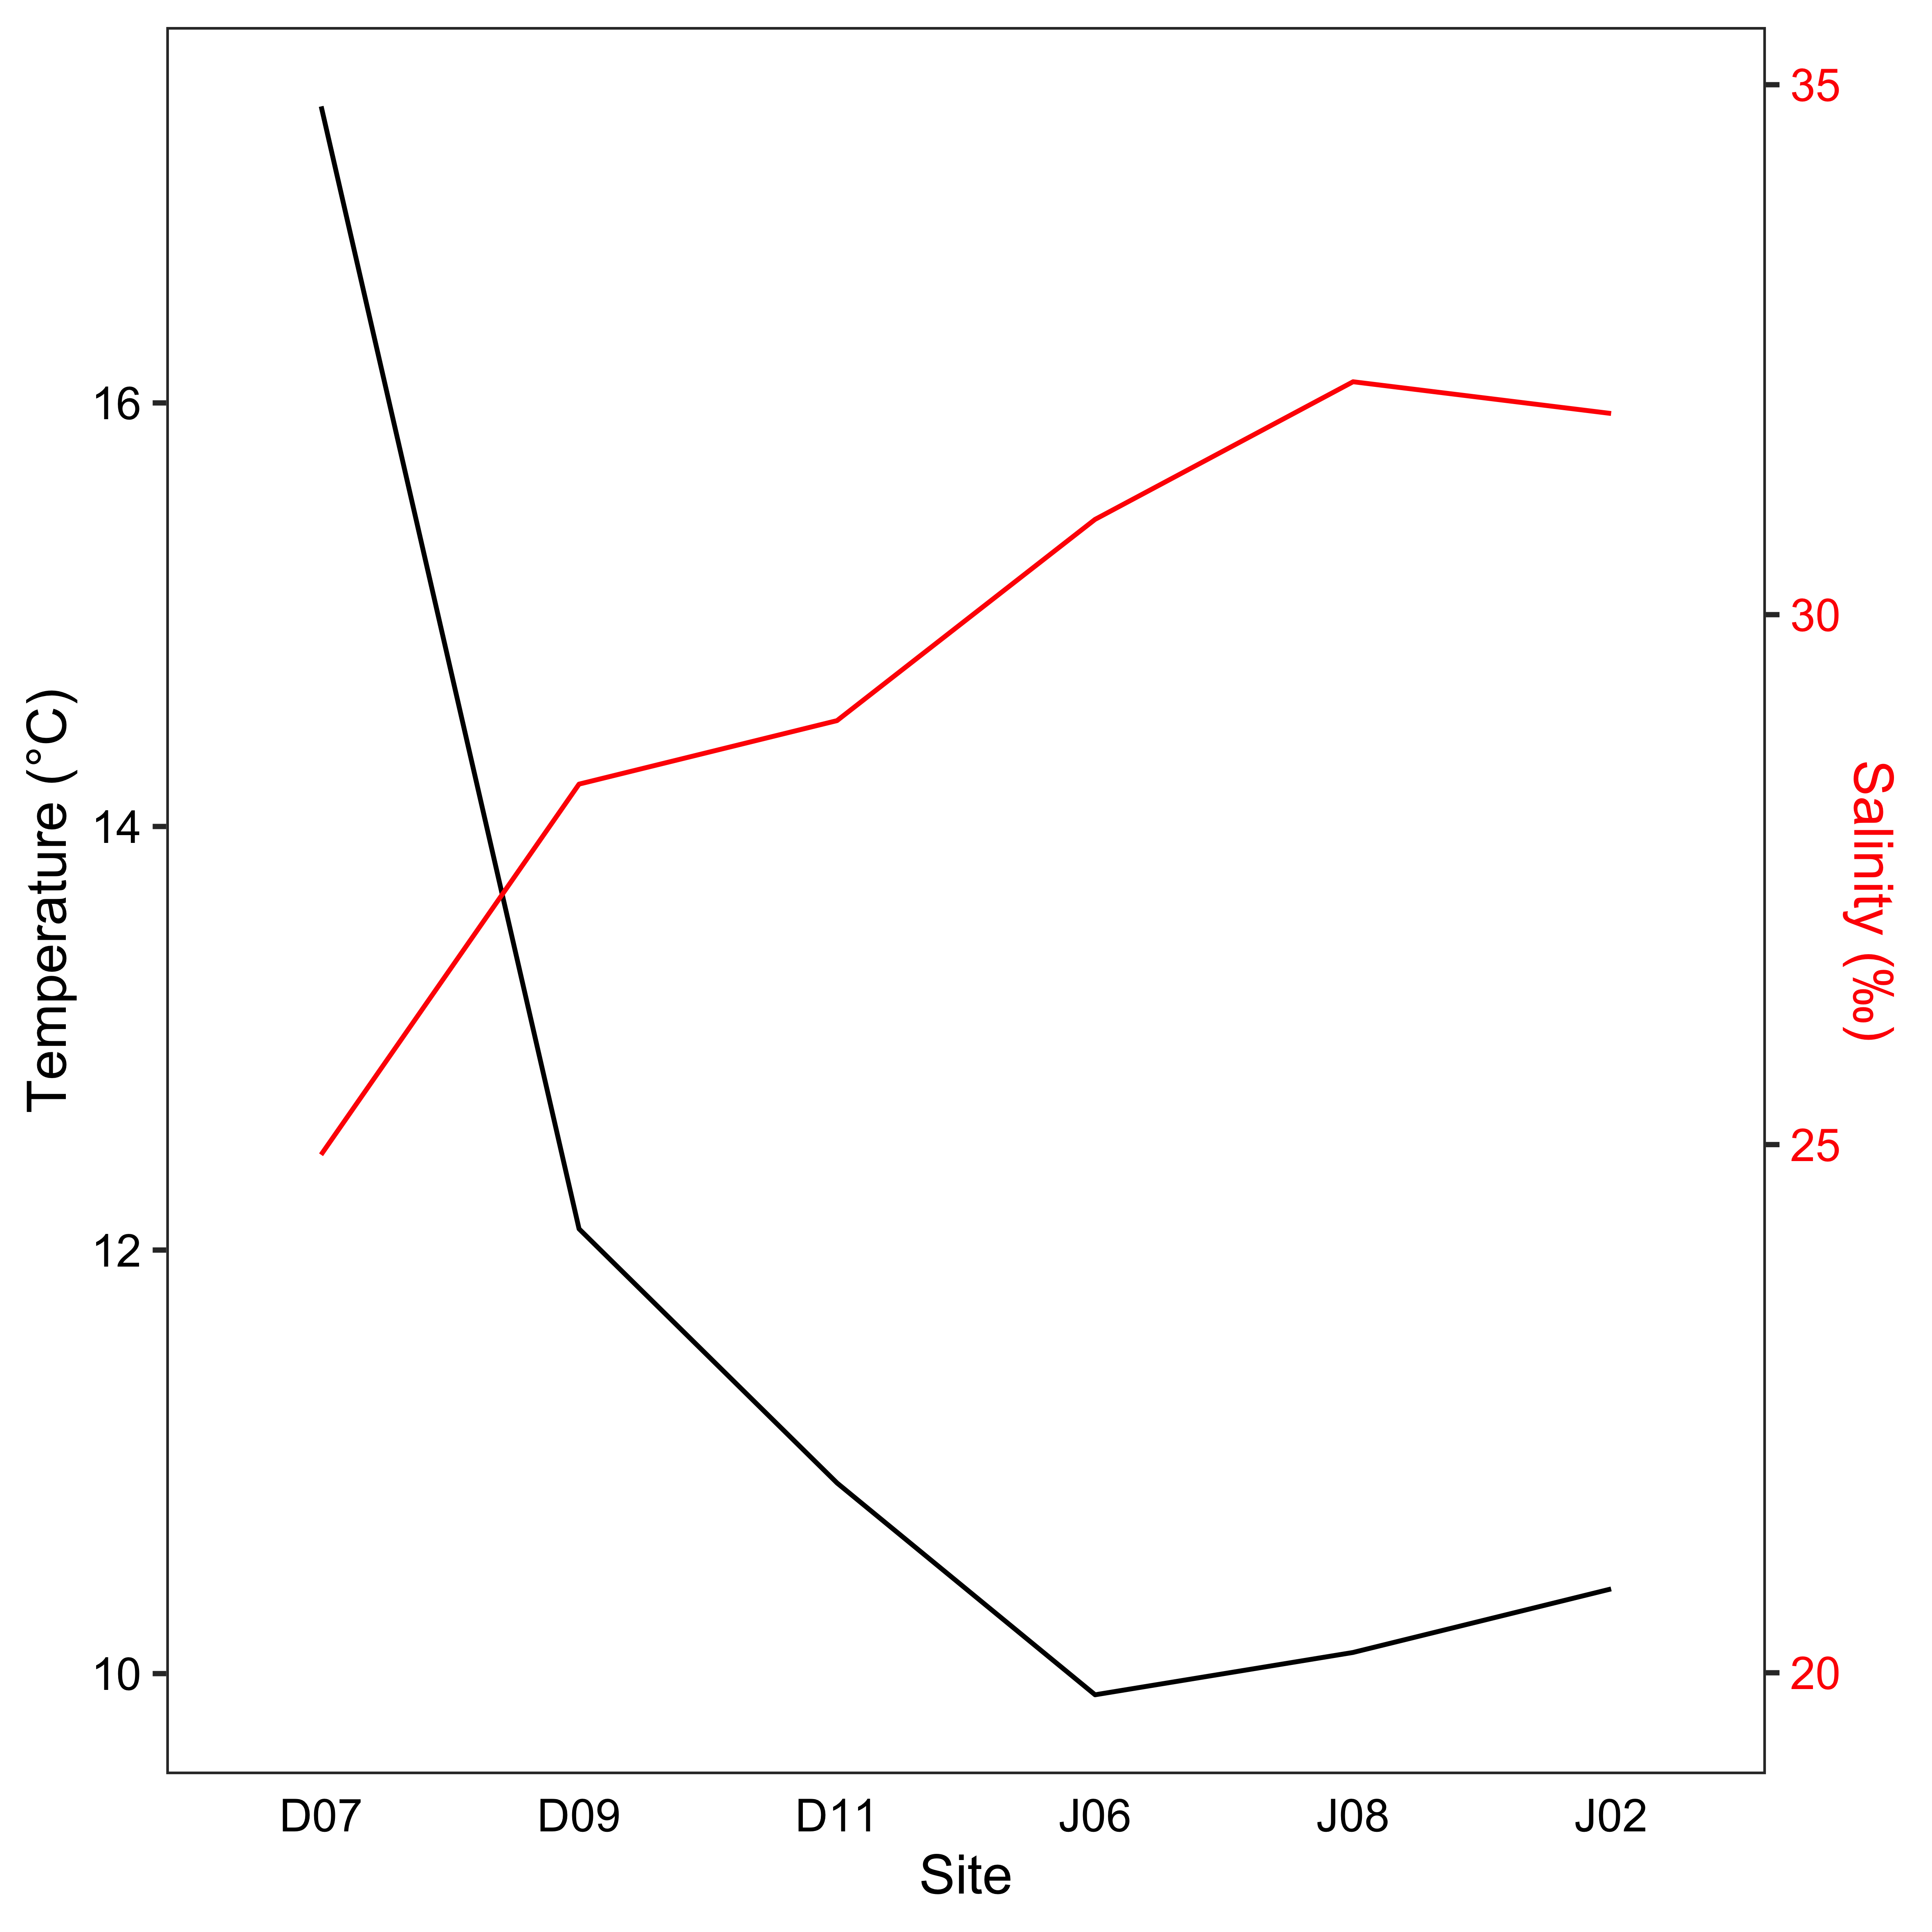

Figure 2.2 Temperature (black) and salinity (red) values paired with the salmon surveys. The sites are listed along the salmon migration pathway from left to right.



Figure 2.3 Biomass of zooplankton, displaying total biomass and contribution by size fractions. “X” indicates that data were missing for site J02.



Figure 2.4 Average relative abundance of zooplankton groups. “Other” includes cladocerans, barnacle larvae and euphausiid eggs.



Figure 2.5 Salmon condition factor K, the red dotted line separates fish in good condition (high weight relative to length, >1) and fish in poor condition (low weight relative to length, <1).



Figure 2.6 Average relative biomass of the main prey groups for juvenile pink (top) and chum salmon (bottom), at each site along the migration route. The ‘Other’ group includes prey such as cyclopoids, fish, polychaetes and pteropods.



Figure 2.7 Non-metric multidimensional scaling (NMDS) ordination of juvenile pink and chum salmon diet composition. Each point represents one salmon stomach, colored by site, and ellipses show standard deviation by region. “Stress” indicates how well the distances between points were retained when displayed in two-dimensions and for this plot, the stress was 0.17.



Figure 2.8 Cluster analysis of juvenile pink and chum diet composition.



Figure 2.9 Gut fullness index (GFI) of juvenile pink and chum salmon. Box plots show the mean (black bar), interquartile range (boxes) and 1.5*inter-quartile range (whiskers) of salmon GFI. The overlaid dark red line indicates dietary overlap between pink and chum salmon (secondary y-axis).



Figure 2.10 Cumulative prey abundance curves for juvenile salmon at each site location. Note: All sampling events included 10 salmon, but empty stomachs detract from total number of stomachs.

## Salmon trophic interactions shift with prey phenology and migration timing

### Introduction

Pacific salmon (*Oncorhynchus spp.*) are heavily relied on and culturally revered all throughout the Pacific Northwest, yet species and stocks are incredibly diverse and specialized. Some species, such as sockeye, chinook and coho salmon spend more of their life cycle in freshwater relative to pink and chum salmon who migrate to sea early in their life. Furthermore, each stock’s migration route and timing depend on the length and complexity of the rivers and location of the spawning habitat, whether it is upper, middle or lower in the larger river systems. Pacific salmon therefore have to cope with a multitude of challenges in both freshwater and marine, such as rising temperatures, droughts, deforestation, pollution and industrialization. Managing these important and unique stocks requires understanding of the fundamental biology underlying salmon migration, especially in the first months at sea, the vulnerable juvenile phase.

There are many different factors affecting the early marine survival of Pacific salmon, including migration run timing and whether it coincides with good quality and quantity of prey. The ocean environment in northern latitudes depends on seasonal cycles of surface layer stratification for phytoplankton growth that stimulates upper trophic levels. The timing of zooplankton phenology affects the size of prey available for migrating juvenile salmon. Over time, evolution has selected for migration run timing that coincides with ideal zooplankton communities. However, climate change shifts these seasonal cycles due to increase in ocean temperatures and freshwater discharge, which can lead to a mismatch of predators and prey.

Salmon diets have also been found to be incredibly variable over time and therefore prey choice and interspecific competition can shift in response to these seasonal and interannual changes.

The size of salmon in relation to size of zooplankton prey is another important factor influenced by salmon size at ocean entry and growth rate during the first few months at sea. The ideal size of prey for juvenile salmon depends on salmon size and mouth gape, therefore large prey may be available in the water column but unavailable as a prey choice for certain salmon.

Seasonal and interannual oceanography, prey dynamics and salmon migration timing are linked to salmon survival and requires a better understanding within the Pacific Northwest. In the context of climate change, the linkages between the environment and struggling salmon stocks may provide more insights into predicting adult returns and improve fish management efforts.

Previous studies in coastal British Columbia have shown Discovery Islands to be very seasonally dynamic, whereas Johnstone Strait is more consistent with no seasonality. Until this current study, there has been no research on juvenile pink and chum salmon for the entirety of the outmigration period in tidally mixed waters. (Compare temporal aspects of other studies)

There is ongoing debate on whether bigger is better is true for juvenile outmigrating salmon. This study will investigate the relationships between juvenile pink and chum salmon foraging and the zooplankton community composition throughout early salmon outmigration. The main research question for this study was were pink and chum food limited and competing throughout outmigration? This study therefore a) quantified juvenile pink and chum salmon diets seasonally and interannually in southern coastal B.C.; b) compared diets to ocean conditions, fish size, and prey size; and c) described how salmon species trophic interactions shifted over time.

### Methods

#### Field sampling

The Hakai Institute’s Juvenile Salmon Program was established in 2015 as a collaboration between the Hakai Institute, the University of British Columbia, Simon Fraser University, the University of Toronto and Salmon Coast Field Station. This ongoing program annually samples juvenile salmon as they migrate through the Discovery Islands and Johnstone Strait during the main outmigration period (May to July). The objective of the program was to improve understanding of the early marine phase of Pacific salmon, particularly factors contributing to health and survival (Hunt et al., 2018). This study focussed on 2015 and 2016, which had good seasonal coverage of pink and chum salmon from late May to around early July.

In the Discovery Islands, 12 sites were sampled in 2015-2016, and in Johnstone Strait, 10 sites were sampled, to provide coverage of all possible salmon migration routes through these regions (Hunt et al., 2018). Sample coverage extended from the northern Strait of Georgia, multiple routes in the Discovery Islands, through Johnstone Strait to the beginning of Queen Charlotte Strait. For this study, 2 sites (one from each region) were selected, in order to obtain a sample size of 10 pink and 10 chum per set. However, 2015 was low in pink salmon abundance due to biennial life patterns and the absence of Fraser River pink salmon (n=212 total) (Figure 2.1). Samples for this analysis were selected from late May, early/mid-June and late June or early July (Table 2.1) to capture the early, peak, and late stages of salmon out-migration (Johnson et al., 2019).

Fish were captured using a purse seine with bunt dimensions of 27 m × 9 m with 13 mm mesh and tow area dimensions of 46 m × 9 m with 76 mm mesh. Once arrived at a site, weather and sea state were recorded, followed by a visual survey of salmon surface activity. The purse seine net was then set on a targeted school of fish. Up to 30 sockeye, 10 pink and 10 chum salmon were retained, and the remaining salmon were counted and released (Hunt et al., 2018). All retained fish were individually euthanized with tricaine methane sulfonate (MS-222) upon removal from the seine net, lengths and weights recorded, and preserved at -196 oC with liquid nitrogen in a dry shipper until the salmon samples were stored in the -80 oC freezer at the lab.

A YSI instrument (model #15B102233 and 15C100324) was used to measure temperature and salinity at the surface and 1-meter depth, recorded while salmon were held for processing in the net. Once the purse seine set had been complete, zooplankton were sampled with a 50 cm diameter ring net with 250 μm mesh net, towed horizontally at the surface. A General Oceanic flowmeter was attached to the zooplankton net to calculate volume filtered for each sample tow. The zooplankton collected were then preserved in 4% formaldehyde for subsequent analysis.

#### Zooplankton and salmon stomach content analysis

In the lab, zooplankton samples were poured over sieves and separated into 250 μm, 1000 μm and 2000 μm size fractions before being weighed and analyzed. Wet weights were measured to the nearest 0.1 mg on an analytical balance, with non-gelatinous and gelatinous groups weighed separately. If necessary, each size fraction of zooplankton was subsampled with a Motodo plankton splitter. Zooplankton were identified to life stage and the finest taxonomic resolution possible, each group was then enumerated and measured with an ocular micrometer.

Wet weight and fork length were recorded for juvenile salmon before dissection to remove the stomachs, which were preserved in 95% ethanol. Prior to analysis, salmon stomachs were removed from ethanol and soaked for 30 minutes in tap water to reduce the brittleness of the sample. The stomach was then dissected open and the food contents removed. The entire food bolus was weighed on an analytical balance and wet weight recorded to the nearest 0.1 mg. The bolus was then placed on a petri dish with water added, and prey rearranged by species, size, life stage and digestive state. Digestive states were defined as 1) fresh prey, intact, 2) semi-fresh prey, with lost appendages or color, 3) semi-digested prey, only identifiable to group, and 4) fully digested prey, unidentifiable. If prey could not be identified to species, it was identified to the most detailed taxonomic group possible, e.g. Ctenophora and Cnidaria jellyfish, collectively grouped as “gelatinous” hereafter. For each prey group, minimum and maximum lengths were measured with an ocular micrometer, individuals were counted, and the group wet weight recorded to nearest 0.1 mg. If a stomach sample had over 1,000 prey of similar size, a ¼ subsample was processed, after removing and recording large and/or rare prey.

#### Data analysis

The spatial variation in prey composition was analyzed using a multivariate approach. Prior to the analysis, rare taxonomic prey categories (occurring in less than three stomachs) were combined into higher level groupings, ignoring “digested food.” Fish stomach content wet weight was multiplied by 1.54 to correct weights for water loss after storage in ethanol (James, 2019). Relative prey biomass for each stomach was calculated and arcsine square root transformed before calculating Bray-Curtis dissimilarity. The dissimilarity matrix was used for non-metric multidimensional scaling (NMDS) ordination and STATS OTHER THAN THIS...

In addition to the multivariate statistics, various indices were calculated from the raw data. Gut fullness indices (GFI) were calculated for each fish, expressed as percent body weight:

GFI = (food bolus weight / fish weight) * 100

Fulton’s condition factor K comparing length-weight relationships of salmon was calculated as:

K = 100,000 * fish weight / (fish fork length)3

Weight was measured in grams and fork length in millimetres, K=1 indicates average condition, >1 means relatively healthy and <1 was poor condition (Beamish et al., 2012; Jones et al., 1999). The Schoener percent similarity index (PSI) for species diet overlap was calculated for each site:

PSI = [Σ (minimum preyip, preyic)] * 100

Where preyip was the proportion by weight of prey *i* in pink salmon stomachs and preyic was the proportion by weight of prey *i* in chum salmon stomachs (Chipps & Garvey, 2006; Krebs, 2013).

The empty stomachs (those with no identifiable prey) in this study were excluded from the multivariate dissimilarity calculations but were included in the calculation of the above indices. The prey taxonomic detail was retained in analyses, but for summary tables and figures, “other” was prey grouped together that does not contribute substantially to diets (<10% weight), e.g. fish larvae/eggs, amphipods, barnacle larvae, bivalve larvae, cladocerans, pteropods, and polychaetes. All analyses were performed in R (v4.0.2.), using the *vegan* package v2.5-6 (Oksanen et al., 2019; R Core Team, 2020).

### Results

#### Environmental conditions

#### Zooplankton

#### Salmon diet composition

#### Salmon stomach fullness

#### Juvenile salmon condition

#### Diet diversity of juvenile salmon

### Discussion

#### Seasonality and prey phenology

#### Interannual variability

#### Predator and prey sizes

#### Salmon trophic interactions

### Conclusion

### Tables

Table 3.1 Sampling during salmon outmigration (May to July) through the Discovery Islands and Johnstone Strait in 2015 and 2016.



Table 3.2 Zooplankton relative abundance (expressed as percent) by major groups.



Table 3.3 Summarized salmon biological data for 2015-2016 in DI-JS, including fork length (FL), wet weight (WW), condition factor K, gut fullness (GFI), number of empty stomachs, dietary overlap between species and richness (number of prey categories), expressed as mean ± standard deviation.



Table 3.4 Diet composition summary (% wet weight) of juvenile salmon by site and year.



### Figures



Figure 3.1 Map of sampling sites for Discovery Islands and Johnstone Strait during May to July 2015-2016. Inset map (left) shows B.C. coast with study location in red.

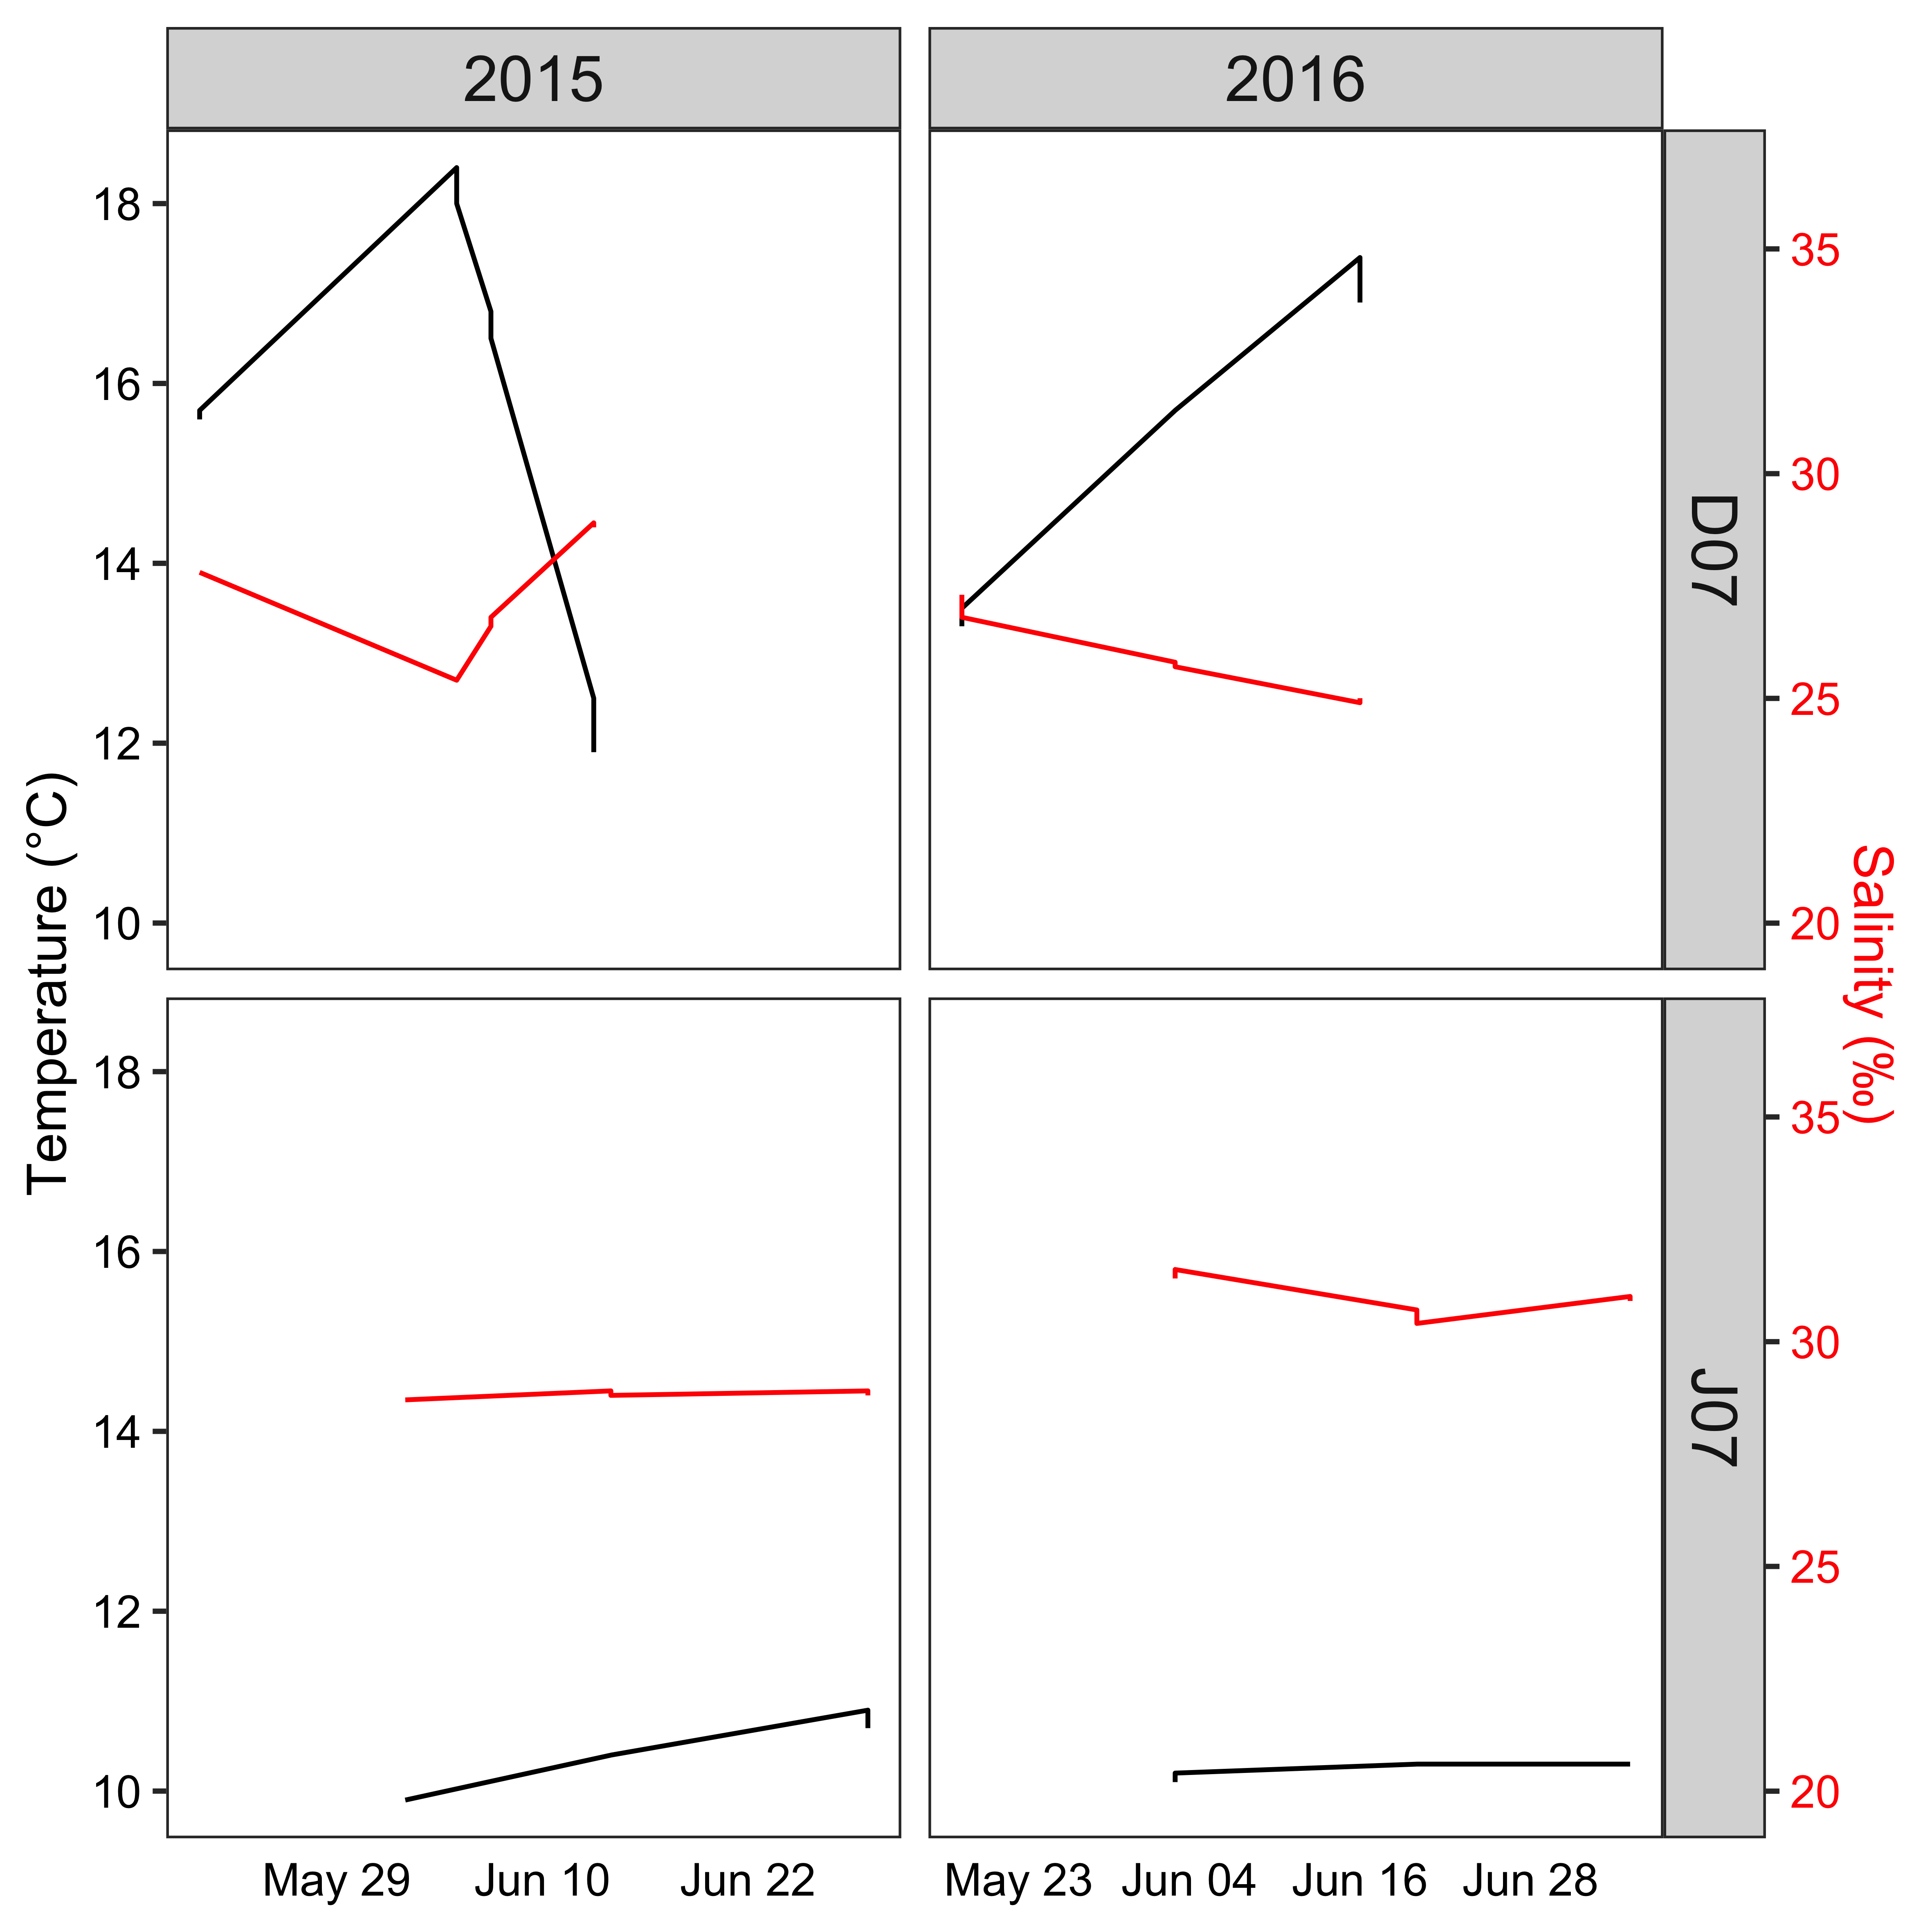

Figure 3.2 Temperature (black) and salinity (red) variables paired with salmon surveys in DI and JS, during the outmigration period in 2015 and 2016.

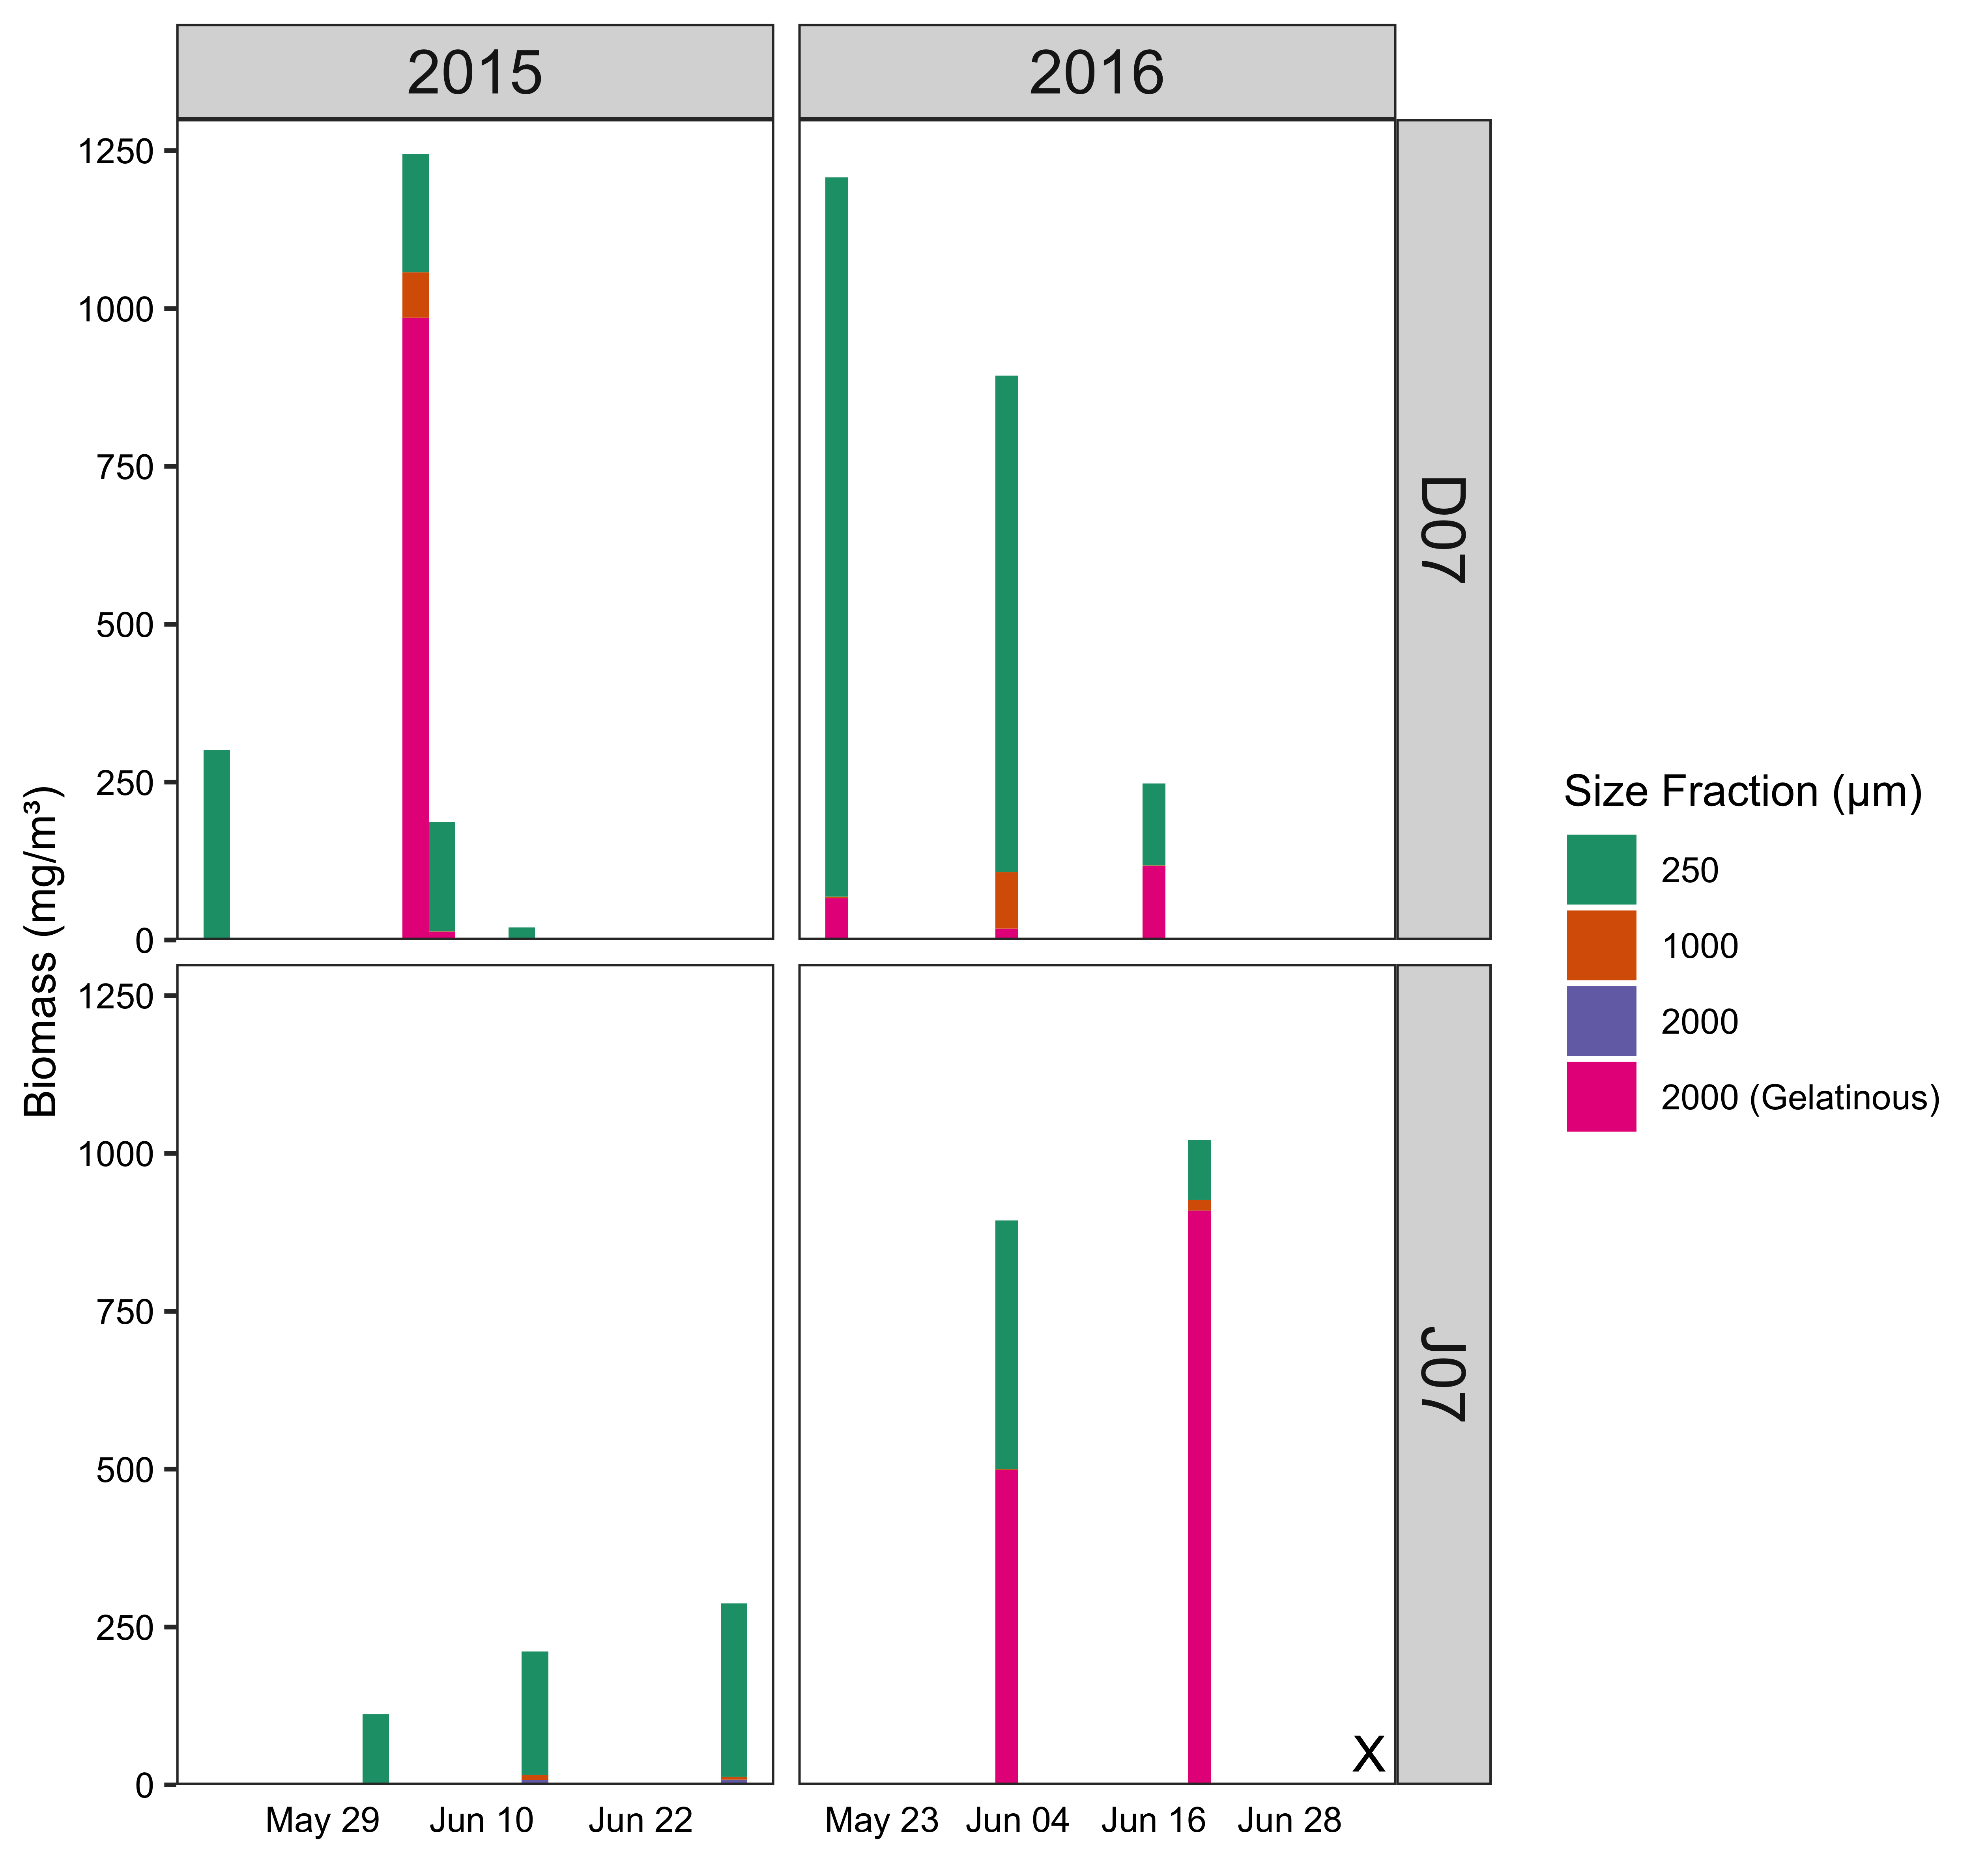

Figure 3.3 Zooplankton biomass by size fraction for 2015-2016. “X” indicates missing data.

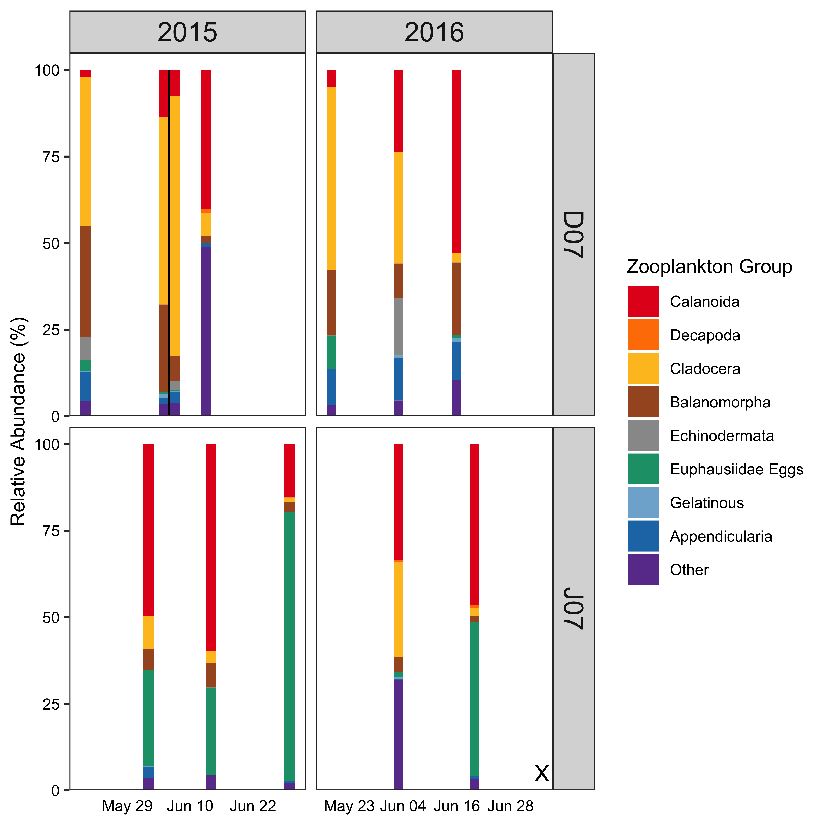

Figure 3.4 Zooplankton relative abundance for site and sampling period in 2015-2016. “X” indicates missing zooplankton data to pair with salmon data. Note: June 5th and 7th 2015 in DI was shown as two separate sampling events due to pink and chum being sampled on different dates.



Figure 3.5 Diet composition of major prey groups by relative biomass of juvenile pink (“PI”, outlined in pink) and chum (“CU”, outlined in dark green) salmon during outmigration in 2015-2016.

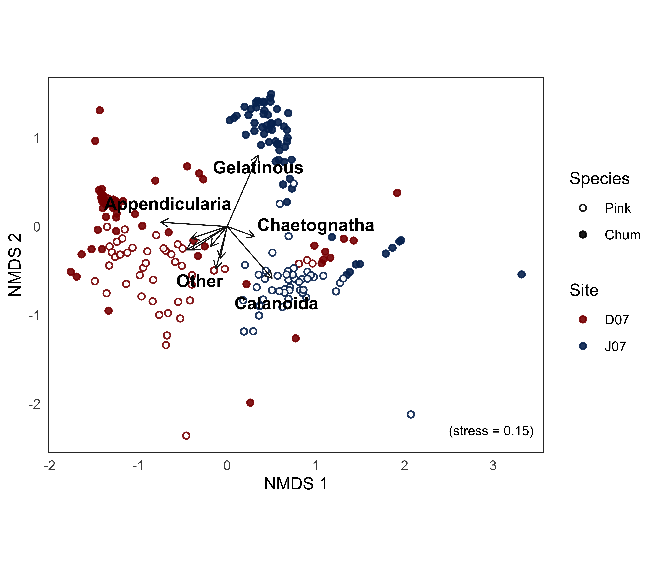

Figure 3.6 Non-metric multidimensional scaling (NMDS) ordination plot of diet composition of pink (open circles) and chum (filled circles) salmon in Discovery Islands (red) and Johnstone Strait (blue) during outmigration (May to July) of 2015 and 2016. Main taxonomic prey groups were overlaid as arrows, with overlapping labels not shown (Euphausiidae eggs, Balanomorpha, Echinodermata, Cladocera, Decapoda).

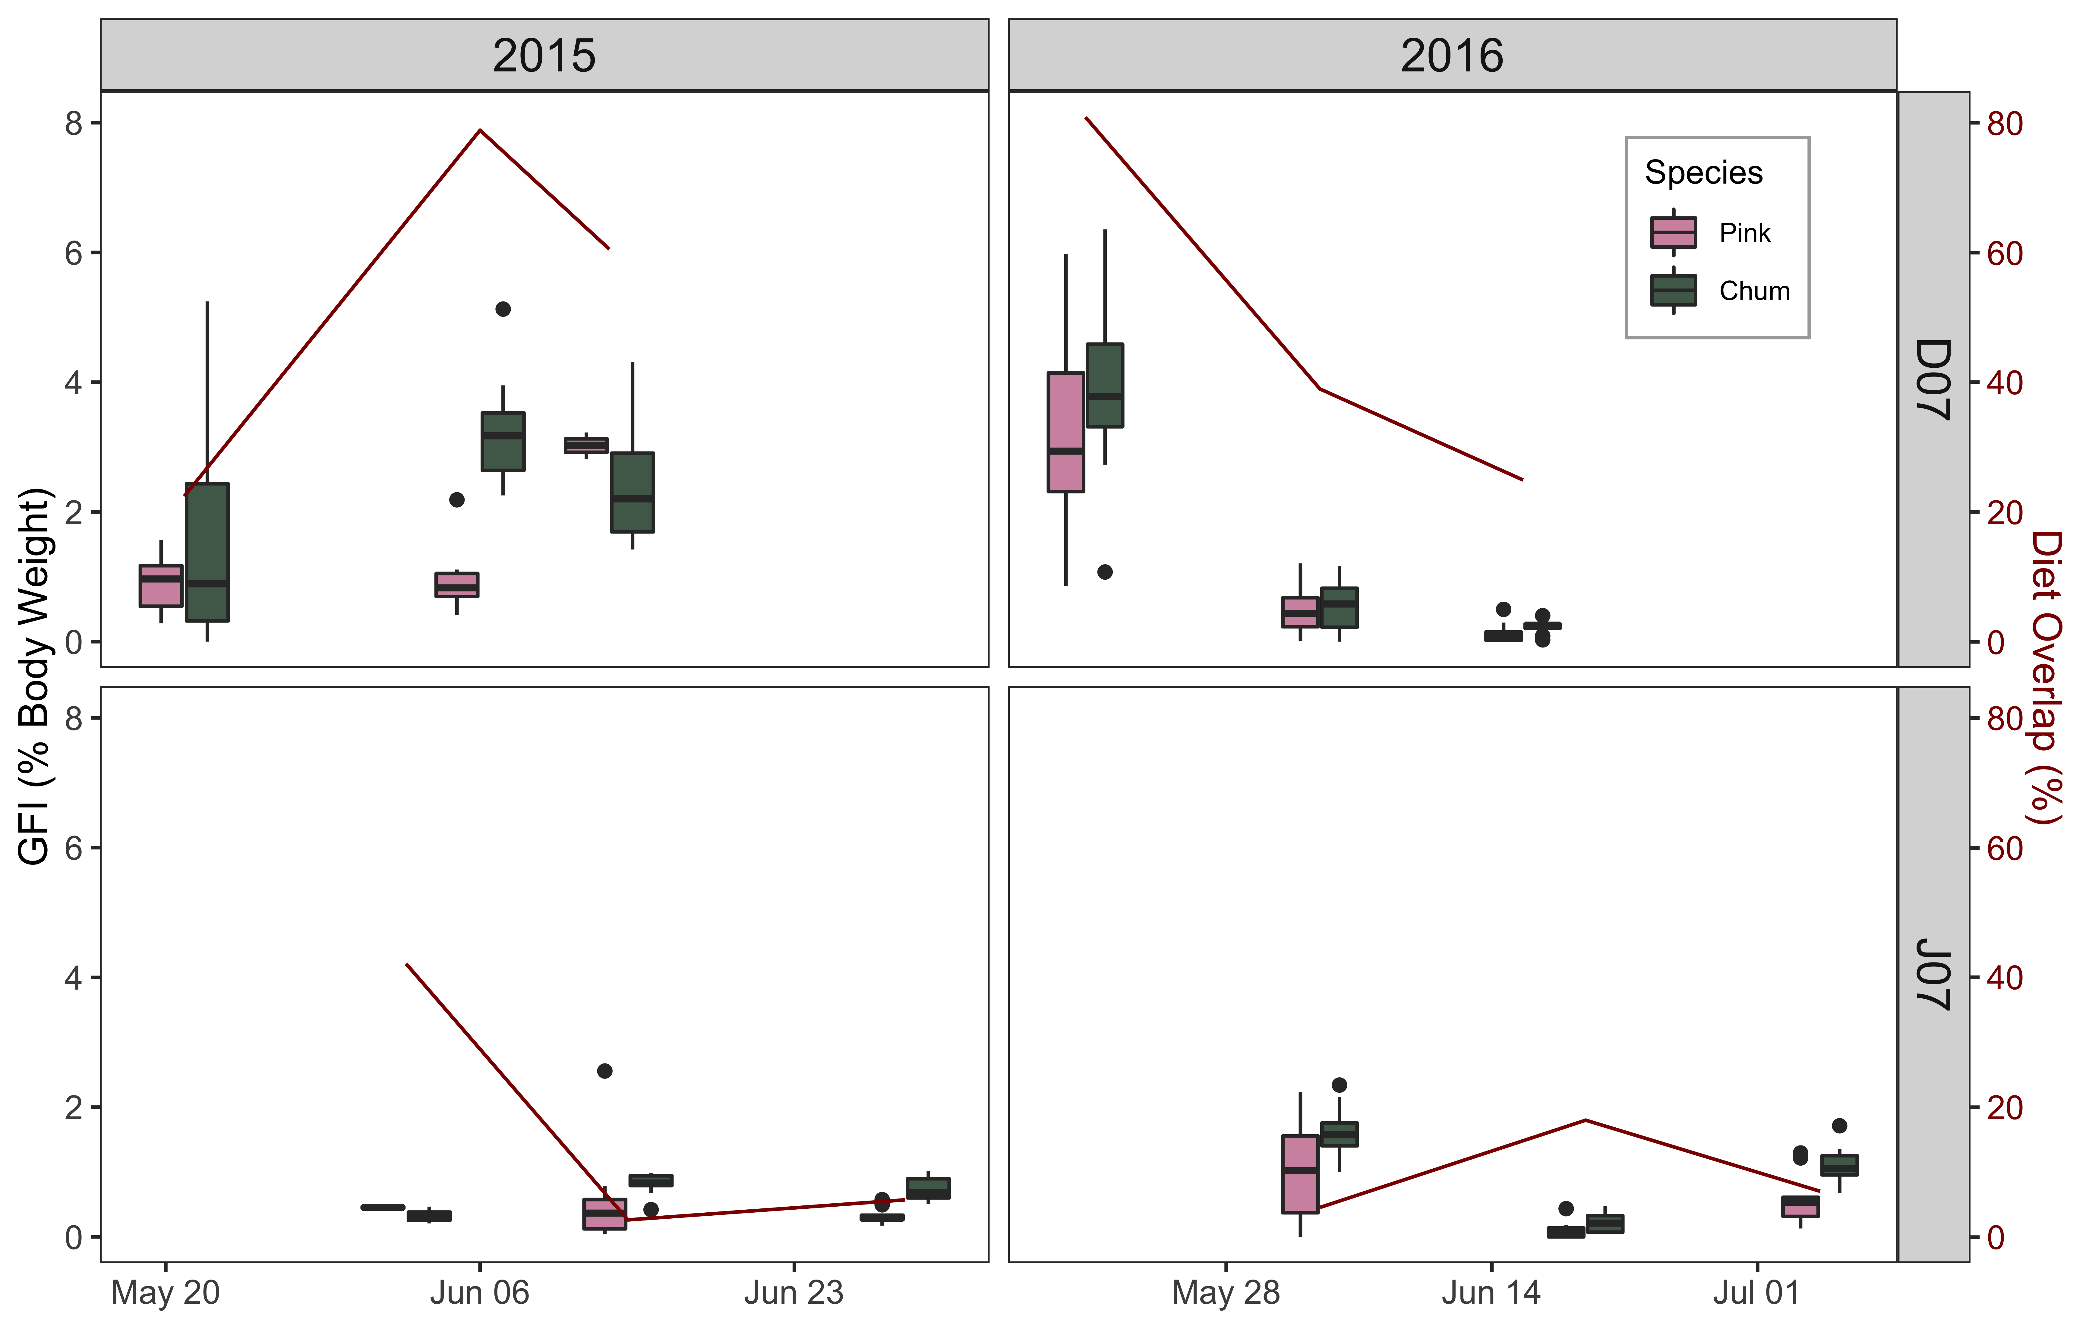

Figure 3.7 Gut fullness indices (GFI) for juvenile pink and chum salmon in DI-JS, 2015-2016, with overlap shown in dark red.



Figure 3.8 Juvenile salmon condition during outmigration through DI-JS in 2015-2016. The red dotted line separates fish in good condition (high weight relative to length, >1) and fish in poor condition (low weight relative to length, <1).

## Conclusion

### Knowledge gap of juvenile pink and chum salmon competition

…

### Diets of juvenile pink and chum salmon in contrasting foraging conditions

…

### Trophic interactions of pink and chum salmon during outmigration

…

### Pink and chum salmon as ecosystem indicators

…

# References

Batten, S. D., Ruggerone, G. T., & Ortiz, I. (2018). Pink Salmon induce a trophic cascade in plankton populations in the southern Bering Sea and around the Aleutian Islands. *Fisheries Oceanography*, *27*(6), 548–559. https://doi.org/10.1111/fog.12276

Beamish, R. J. (2017). What the past tells us about the future of Pacific salmon research. *Fish and Fisheries*, *18*(6), 1161–1175. https://doi.org/10.1111/faf.12231

Beamish, R. J., & Mahnken, C. (2001). A critical size and period hypothesis to explain natural regulation of salmon abundance and the linkage to climate and climate change. *Progress in Oceanography*, *49*(1–4), 423–437. https://doi.org/10.1016/S0079-6611(01)00034-9

Beamish, R. J., Neville, C., Sweeting, R., & Lange, K. (2012). The synchronous failure of juvenile pacific salmon and herring production in the strait of georgia in 2007 and the poor return of sockeye salmon to the Fraser river in 2009. *Marine and Coastal Fisheries*, *4*(1), 403–414. https://doi.org/10.1080/19425120.2012.676607

Beamish, R. J., Pearsall, I. a, & Healey, M. C. (2003). A history of the research on the early marine life of Pacific salmon off Canada’s Pacific coast. *NPAFC Bulletin*, *3*(3), 1–40.

Beamish, R. J., Sweeting, R. M., Neville, C. M., & Lange, K. L. (2010). Competitive Interactions Between Pink Salmon and Other Juvenile Pacific Salmon in the Strait of Georgia. *NPAFC Doc. 1284*, *January*.

Brodeur, R. D. (1990). *A synthesis of the food habits and feeding ecoloy of salmonids in marine waters of the North Pacific*. *(INPFC Doc.) FRI*-*UW*-*9016*, 38 p. https://doi.org/FRI-UW-9016

Brodeur, R. D. a, Daly, E. A., Sturdevant, M. V., Miller, T. W., Moss, J. H., Thiess, M. E., Trudel, M., Weitkamp, L. A., Armstrong, J., & Norton, E. C. (2007). Regional comparisons of juvenile salmon feeding in coastal marine waters off the West Coast of North America. *American Fisheries Society Symposium*, *57*(February 2015), 183.

Chase, J. M., & Leibold, M. A. (2003). Introduction: History, context, and purpose. In *Ecological Niches: Linking Classical and Contemporary Approaches* (pp. 1–18).

Chebanova, V. V., Frenkel, S. E., & Zelenikhina, G. S. (2018). Relation of feeding in juvenile chum salmon (Oncorhynchus keta) and pink salmon (o. gorbuscha) to abundance of zooplankton in coastal waters of the prostor bay (iturup island). *Journal of Ichthyology*, *58*(5), 741–750. https://doi.org/10.1134/s0032945218050041

Chipps, S. R., & Garvey, J. E. (2006). Assessment of Food Habits and Feeding Patterns. *American Fischery Society*, *May*, 42.

Choi, J. S., Jung, Y. J., Hong, N. H., Hong, S. H., & Park, J. W. (2018). Toxicological effects of irregularly shaped and spherical microplastics in a marine teleost, the sheepshead minnow (Cyprinodon variegatus). *Marine Pollution Bulletin*, *129*(1), 231–240. https://doi.org/10.1016/j.marpolbul.2018.02.039

Collicutt, B., Juanes, F., & Dudas, S. E. (2019). Microplastics in juvenile Chinook salmon and their nearshore environments on the east coast of Vancouver Island. *Environmental Pollution*, *244*, 135–142. https://doi.org/10.1016/j.envpol.2018.09.137

Costalago, D., Forster, I., Nemcek, N., Neville, C., Perry, R. I., Young, K., & Hunt, B. P. V. (2020). Seasonal and spatial dynamics of the planktonic trophic biomarkers in the Strait of Georgia (northeast Pacific) and implications for fish. *Scientific Reports*, *10*(1), 1–12. https://doi.org/10.1038/s41598-020-65557-1

Daly, E. A., Moss, J. H., Fergusson, E., & Debenham, C. (2019). Feeding ecology of salmon in eastern and central Gulf of Alaska. *Deep-Sea Research Part II: Topical Studies in Oceanography*, *165*(June), 329–339. https://doi.org/10.1016/j.dsr2.2019.06.006

DFO. (2020). *Salmon Southern BC Integrated Fisheries Management Plan*. http://www2.mar.dfo-mpo.gc.ca/fisheries/res/imp/2000grndfish.htm

Duffy, E. J., Beauchamp, D. A., & Buckley, R. M. (2005). Early marine life history of juvenile Pacific salmon in two regions of Puget Sound. *Estuarine, Coastal and Shelf Science*. https://doi.org/10.1016/j.ecss.2005.02.009

Garner, K., & Parfitt, B. (2006). First Nations, Salmon Fisheries and the Rising Importance of Conservation. In *Report to the Pacific Fisheries Resource Conservation Council*.

Gill, A. B. (2003). The dynamics of prey choice in fish: The importance of prey size and satiation. *Journal of Fish Biology*, *63*(SUPPL. A), 105–116. https://doi.org/10.1111/j.1095-8649.2003.00214.x

Godin, J. G. J. (1981). Daily patterns of feeding behavior, daily rations, and diets of juvenile pink salmon (oncorhynchus gorbuscha) in two marine bays of british columbia. *Canadian Journal of Fisheries and Aquatic Sciences*, *38*(1), 10–15. https://doi.org/10.1139/f81-002

Groot, C., & Margolis, L. (1991). *Pacific salmon life histories*. University of British Columbia Press.

Gulbransen, C. O. M. (2014). *Feeding in troubled waters: a comparative diet analysis of pink (Oncorhynchus gorbuscha) and chum (O. keta) salmon during their first months at sea in the Broughton Archipelago, British Columbia*.

Hardin, G. (1960). The Competitive Exclusion Principle. *Science*, *131*, 1292–1297.

Harrison, P. J., Fulton, J. D., Taylor, F. J. R., & Parsons, T. R. (1983). Review of the biological oceanography of the Strait of Georgia: pelagic environment. *Canadian Journal of Fisheries and Aquatic Sciences*, *40*(7), 1064–1094. https://doi.org/10.1139/f83-129

Healey, M.C. (1991). *Diets and Feeding Rates of Juvenile Pink, Chum, and Sockeye Salmon in Hecate Strait, British Columbia*. *120*, 303–318. https://doi.org/10.1577/1548-8659(1991)120

Healey, Michael C. (1979). Detritus and Juvenile Salmon Production in the Nanaimo Estuary: II. Meiofauna Available as Food to Juvenile Chum Salmon (Oncorhynchus keta). *Journal of the Fisheries Research Board of Canada*, *36*(5), 497–503. https://doi.org/10.1139/f79-073

Healey, Michael C. (2009). Resilient salmon, resilient fisheries for British Columbia, Canada. *Ecology and Society*, *14*(1). https://doi.org/10.5751/ES-02619-140102

Hunt, B. P. V., Johnson, B. T., Godwin, S. C., Krkošek, M., Pakhomov, E. A., & Rogers, L. A. (2018). The Hakai Institute Juvenile Salmon Program : Early Life History Drivers of Marine Survival in Sockeye , Pink and Chum Salmon in British Columbia. *North Pacific Anadromous Fish Commission*, 14.

James, S. E. (2019). *Foraging Ecology of Juvenile Fraser River Sockeye Salmon Across Mixed and Stratified Regions of the Early Marine Migration*. https://doi.org/10.1017/CBO9781107415324.004

James, S. E., Pakhomov, E. A., Mahara, N., & Hunt, B. P. V. (2020). Running the trophic gauntlet: Empirical support for reduced foraging success in juvenile salmon in tidally mixed coastal waters. *Fisheries Oceanography*, *29*(3), 0–2. https://doi.org/10.1111/fog.12471

Jenkins, E. (2011). *Trophic niche and foodweb dynamics within and among juvenile salmon species in years of contrasting ocean conditions*.

Johnson, B., Gan, J., Godwin, S., Krkosek, M., & Hunt, B. (2019). Juvenile Salmon Migration Observations in the Discovery Islands and Johnstone Strait in 2018 Compared to 2015–2017. *Technical Report*, *15*, 31–39. https://doi.org/10.23849/npafctr15/31.39.

Johnson, S. P., & Schindler, D. E. (2009). Trophic ecology of Pacific salmon (Oncorhynchus spp.) in the ocean: A synthesis of stable isotope research. *Ecological Research*, *24*(4), 855–863. https://doi.org/10.1007/s11284-008-0559-0

Jones, R. E., Petrell, R. J., & Pauly, D. (1999). Using modified length-weight relationships to assess the condition of fish. *Aquacultural Engineering*, *20*(4), 261–276. https://doi.org/10.1016/S0144-8609(99)00020-5

Journey, M. L., Trudel, M., Young, G., & Beckman, B. R. (2018). Evidence for depressed growth of juvenile Pacific salmon (Oncorhynchus) in Johnstone and Queen Charlotte Straits, British Columbia. *Fisheries Oceanography*, *27*(2), 174–183. https://doi.org/10.1111/fog.12243

Khangaonkar, T., Long, W., & Xu, W. (2017). Assessment of circulation and inter-basin transport in the Salish Sea including Johnstone Strait and Discovery Islands pathways. *Ocean Modelling*, *109*, 11–32. https://doi.org/10.1016/j.ocemod.2016.11.004

Krebs, C. J. (2013). Niche measures and resource preferences. In *Ecological Methodology* (pp. 597–651).

LeBrasseur, R. J., & Parker, R. R. (1964). Growth Rate of Central British Columbia Pink Salmon (Oncorhynchus gorbuscha). *Journal of the Fisheries Research Board of Canada*, *21*(5), 1101–1128. https://doi.org/10.1139/f64-100

Levings, C. D. (2016). *Ecology of salmonids in estuaries around the world: adaptations, habitats, and conservation*. University of British Columbia Press.

Mackas, D. L., Thomson, R. E., & Galbraith, M. (2001). Changes in the zooplankton community of the British Columbia continental margin, 1985-1999, and their covariation with oceanographic conditions. *Canadian Journal of Fisheries and Aquatic Sciences*, *58*(4), 685–702. https://search.proquest.com/docview/219273927?pq-origsite=summon&accountid=14656

Mahara, N. (2018). *Zooplankton Community Composition Across a Range of Productivity Regimes in Coastal British Columbia*.

Malick, M. J., & Cox, S. P. (2016). Regional-scale declines in productivity of pink and chum salmon stocks in western North America. *PLoS ONE*, *11*(1), 1–23. https://doi.org/10.1371/journal.pone.0146009

Manzer, J. I. (1969). *Stomach Contents of Juvenile Pacific Salmon in Chatham Sound and Adjacent Waters*. *26*, 2219–2223.

Marushka, L., Kenny, T. A., Batal, M., Cheung, W. W. L., Fediuk, K., Golden, C. D., Salomon, A. K., Sadik, T., Weatherdon, L. V., & Chan, H. M. (2019). Potential impacts of climate-related decline of seafood harvest on nutritional status of coastal First Nations in British Columbia, Canada. *PLoS ONE*, *14*(2), 1–24. https://doi.org/10.1371/journal.pone.0211473

Mckinnell, S., Curchitser, E., Groot, K., Kaeriyama, M., & Trudel, M. (2014). Oceanic and atmospheric extremes motivate a new hypothesis for variable marine survival of Fraser River sockeye salmon. *Fisheries Oceanography*, *23*(4), 322–341. https://doi.org/10.1111/fog.12063

Mcqueen, D., & Ware, D. (2006). *Handbook of Physical, Chemical, Phytoplankton, and Zooplankton Data from Hecate Strait, Dixon Entrance, Goose Island Bank and Queen Charlotte Sound*. 133. http://skeenasalmonprogram.ca/libraryfiles/lib_236.pdf

Oksanen, J., Guillaume Blanchet, F., Friendly, M., Kindt, R., Legendre, P., McGlinn, D., Minchin, P. R., O’Hara, R. B., Simpson, G. L., Solymos, P., Stevens, M. H. H., Szoecs, E., & Wagner, H. (2019). *vegan: Community Ecology Package*. R package version 2.5-6. https://cran.r-project.org/web/packages/vegan/index.html

Orsi, J. A., Wertheimer, A. C., Sturdevant, M. V., Fergusson, E. A., Mortensen, D. G., & Wing, B. L. (2004). Juvenile chum salmon consumption of zooplankton in marine waters of southeastern Alaska: A bioenergetics approach to implications of hatchery stock interactions. *Reviews in Fish Biology and Fisheries*, *14*(3), 335–359. https://doi.org/10.1007/s11160-004-3813-8

Osgood, G. J., Kennedy, L. A., Holden, J. J., Hertz, E., McKinnell, S., & Juanes, F. (2016). Historical diets of forage fish and juvenile pacific salmon in the strait of Georgia, 1966-1968. *Marine and Coastal Fisheries*, *8*(1), 580–594. https://doi.org/10.1080/19425120.2016.1223231

Pearson, W. H., Deriso, R. B., Elston, R. A., Hook, S. E., Parker, K. R., & Anderson, J. W. (2012). Hypotheses concerning the decline and poor recovery of Pacific herring in Prince William Sound, Alaska. *Reviews in Fish Biology and Fisheries*, *22*(1), 95–135. https://doi.org/10.1007/s11160-011-9225-7

Perry, R. I., Hargreaves, N. B., Waddell, B. J., & Mackas, D. L. (1996). Spatial variations in feeding and condition of juvenile pink and chum salmon off Vancouver Island, British Columbia. *Fisheries Oceanography*, *5*(2), 73–88. https://doi.org/10.1111/j.1365-2419.1996.tb00107.x

Pocheville, A. (2015). The ecological niche: History and recent controversies. In *Handbook of Evolutionary Thinking in the Sciences* (Issue January). https://doi.org/10.1007/978-94-017-9014-7_26

Quinn, T. P. (2018). *The behaviour and ecology of Pacific salmon and trout* (Second). University of Washington Press.

R Core Team. (2020). *R: A Language and Environment for Statistical Computing*. R Foundation for Statistical Computing. Vienna, Austria. https://www.r-project.org/

Ruggerone, G. T., & Irvine, J. R. (2018). Numbers and Biomass of Natural- and Hatchery-Origin Pink Salmon, Chum Salmon, and Sockeye Salmon in the North Pacific Ocean, 1925–2015. *Marine and Coastal Fisheries*, *10*(2), 152–168. https://doi.org/10.1002/mcf2.10023

Ruggerone, G. T., & Nielsen, J. L. (2004). Evidence for competitive dominance of Pink salmon (Oncorhynchus gorbuscha) over other Salmonids in the North Pacific Ocean. *Reviews in Fish Biology and Fisheries*, *14*(3), 371–390. https://doi.org/10.1007/s11160-004-6927-0

Ruggerone, G. T., Springer, A. M., Shaul, L. D., & van Vliet, G. B. (2019). Unprecedented biennial pattern of birth and mortality in an endangered apex predator, the southern resident killer whale, in the eastern North Pacific Ocean. *Marine Ecology Progress Series*, *608*(1), 291–296. https://doi.org/10.3354/meps12835

Springer, A. M., Van Vliet, G. B., Bool, N., Crowley, M., Fullagar, P., Lea, M. A., Monash, R., Price, C., Vertigan, C., & Woehler, E. J. (2018). Transhemispheric ecosystem disservices of pink salmon in a Pacific Ocean macrosystem. *Proceedings of the National Academy of Sciences of the United States of America*, *115*(22), E5038–E5045. https://doi.org/10.1073/pnas.1720577115

Sturdevant, M. V., Fergusson, E. A., Orsi, J. A., & Wertheimer, A. C. (2004). Diel feeding and gastric evacuation of juvenile pink and chum salmon in Icy Strait, southeastern Alaska, May--September 2001. *North Pacific Anadromous Fish Commission Technical Report*, *5*(5), 107–109.

Sturdevant, M. V, Fergusson, E. A., Orsi, J. A., & Wertheimer, A. C. (2002). *Diel Feeding of Juvenile Pink, Chum, and Coho Salmon in Icy Strait, Southeastern Alaska, May–September 2001*.

Tadokoro, K., Ishida, Y., Davis, N. D., Ueyanagi, S., & Sugimoto, T. (1996). Change in chum salmon (Oncorhynchus keta) stomach contents associated with fluctuation of pink salmon (O. gorbuscha) abundance in the central subarctic Pacific and Bering Sea. *Fisheries Oceanography*, *5*(2), 89–99. https://doi.org/10.1111/j.1365-2419.1996.tb00108.x

Weingartner, T., Eisner, L., Eckert, G. L., & Danielson, S. (2009). Southeast Alaska: Oceanographic habitats and linkages. *Journal of Biogeography*, *36*(3), 387–400. https://doi.org/10.1111/j.1365-2699.2008.01994.x

Welch, D. W. (1997). Anatomical specialization in the gut of Pacific salmon (Oncorhynchus): Evidence for oceanic limits to salmon production? *Canadian Journal of Zoology*, *75*(6), 936–942. https://doi.org/10.1139/z97-112

Wyllie de Echeverria, V. R., & Thornton, T. F. (2019). Using traditional ecological knowledge to understand and adapt to climate and biodiversity change on the Pacific coast of North America. *Ambio*, *48*(12), 1447–1469. https://doi.org/10.1007/s13280-019-01218-6

# Appendix

Table A.1 Diet composition (% wet weight) summary of juvenile salmon for each sampling date 2015-2016.

